**PROJECT REPORT ON**

**“ONLINE VOTING SYSTEM”**

Submitted for partial fulfilment for the final year of

**BACHELOR OF TECHNOLOGY**

Degree in

**INFORMATION TECHNOLOGY**

**Submitted by:**

|  |  |
| --- | --- |
| **Akhilendra Dwivedi**  **Durgvijay Maurya** | **[2001660130007]**  **[2001660130024]** |
| **Jatin Pal** | **[2001660130028]** |
|  |  |
|  |  |

Under the core guidance of

**Dr. ABHISHEK PRABHAKAR**

**Mr. KAPIL KUMAR PANDEY**



**Dr. AMBEDKAR INSTITUTE OF TECHNOLOGY FOR DIVYANGJAN KANPUR, UTTAR PRADESH**

**Dr. A.P.J. ABDUL KALAM TECHNICAL UNIVERSITY, LUCKNOW**

**(Session 2023-2024)**

## TABLE OF CONTENTS

DECLARATION................................................................................................................4

CERTIFICATE...................................................................................................................5

ACKNOWLWDGEMENT.................................................................................................6

ABSTRACT.......................................................................................................................7

CHAPTER 1: INTRODUCTION.............................................................................8

1.1 Background

1.2 Objectives

1.3 Scope

1.4 Significance of the Project

CHAPTER 2: LITERATURE REVIEW...............................................................11

2.1 Overview of Voting Systems

2.2 Electronic Voting Systems

2.3 Security in Electronic Voting

2.4 Technologies Used in Online Voting

CHAPTER 3: SYSTEM REQUIREMENTS.....................................................17

3.1 Functional Requirements

3.2 Non-Functional Requirements

3.3 User Requirements

3.4 System Constraints

3.5 Software Requirements

CHAPTER 4: SYSTEM DESIGN.....................................................................22

4.1 Architecture Design

4.2 Database Design

CHAPTER 5: IMPLEMENTATION..................................................................27

5.1 Backend Development

5.2 Frontend Development

5.3 Integration of Components

CHAPTER 6: PROJECT SHOWCASE............................................................39

6.1 Front Interface

6.2 Instruction Section

6.3 Secure Registration for New Applicants

6.4 Voter Login

6.5 Profile Section

6.6 Voting Rules

6.7 Members List

6.8 About us Section

6.9 Result list

CHAPTER 7: TESTING AND EVALUATION...............................................54

7.1 Testing Methodology

7.2 Unit Testing

7.3 Tools and Strategy

7.4 User Acceptance Testing (UAT)

CHAPTER 8: RESULTS AND DISCUSSION.................................................80

8.1 System Performance

8.2 User Feedback

8.3 Security Analysis

CHAPTER 9: CONCLUSION...............................................................................85

CHAPTER 10: FUTURE SCOPE.........................................................................86

CHAPTER 11: REFERENCES..............................................................................87

## DECLARATION

I hereby declare that this submission is my own work and that, to the best of my knowledge and belief, it contains no material previously published or written by another person nor material which to a substantial extent has been accepted for the award of any other degree or diploma of the university or other institute of higher learning, except where due acknowledgment has been made in the text.

|  |  |
| --- | --- |
| **Akhilendra Dwivedi** | **[2001660130007]** |
| **Durgvijay Maurya** | **[2001660130024]** |
| **Jatin Pal** | **[2001660130028]** |
|  |  |

## CERTIFICATE

This is to certify that Project Report entitled “**Online Voting System**” which is submitted by Akhilendra Dwivedi, Durgvijay Maurya, Jatin Pal in partial fulfilment of the requirement for the award of degree B. Tech. in Department of Information Technology of is a record of the candidate own work carried out by him under my/our supervision and this is not copied from anywhere else.

**Mr. ABHISHEK PRABHAKAR**

(Head of Department)

Information Technology

**ACKNOWLEDGEMENT**

We would like to thank all those who have contributed to the completion of the project and helped us with valuable suggestion for improvement. We are extremely grateful to Abhishek Prabhakar, head of department, for proving us with best facilities and atmosphere for the creative work, guidance and encouragement. I would like to thank our guide Abhishek Prabhakar, for all the help and support extend to us. I would also like to thank all the staff members of my college and friends for extending their cooperation during our project.

|  |  |
| --- | --- |
| **Akhilendra Dwivedi** | **[2001660130007]** |
| **Durgvijay Maurya** | **[2001660130024]** |
| **Jatin Pal** | **[2001660130028]** |
|  |  |

## ABSTRACT

This project report presents the development of an online voting system using the MERN stack (MongoDB, Express.js, React, Node.js). The objective of the project was to create a secure, efficient, and user-friendly platform for conducting elections electronically. The system allows registered users to cast their votes securely from any location with internet access.

The project began with a thorough analysis of existing voting systems and their limitations. Based on this analysis, the system's requirements were gathered, including functional and non-functional requirements, user requirements, and system constraints. The system design phase involved the creation of use case diagrams, system architecture, and database schema.

The implementation phase included setting up the development environment, developing the backend with Node.js and Express.js, and creating the frontend with React. The components were integrated, and the system was deployed using platforms such as Render and MongoDB Atlas. Testing was conducted to ensure the system's functionality, including unit testing, integration testing, and user acceptance testing.

This report details an online voting system built with the MERN stack. Analyzing existing systems' weaknesses, the project defines requirements and designs the system architecture. Back-end (Node/Express) and front-end (React) are developed, integrated, and deployed. Rigorous testing (unit, integration, user acceptance) ensures functionality. Results include performance evaluation, user feedback, security analysis, and comparisons to existing systems. The project concludes that the MERN stack is viable for online voting, contributing to the field and laying the groundwork for future advancements.

## CHAPTER 1 INTRODUCTION

## 1.1 Background

The process of voting is a cornerstone of democratic societies, allowing citizens to elect representatives and make decisions on various issues. Traditional voting methods, which include paper ballots and manual counting, have been used for centuries but are often fraught with inefficiencies, inaccuracies, and potential for fraud. With advancements in technology, electronic voting systems have been developed to address these challenges. However, these systems also come with their own set of issues, such as security vulnerabilities and accessibility barriers.

The emergence of online voting systems seeks to combine the convenience of digital technology with the integrity required for elections. By leveraging modern web technologies, it is possible to create a system that not only ensures accurate and efficient vote counting but also provides robust security measures to protect against tampering and fraud. This project aims to develop an online voting system using the MERN stack, which consists of MongoDB, Express.js, React, and Node.js, to create a secure, scalable, and user-friendly voting platform.

## 1.2 Objectives

The primary objectives of this project are:

Develop a Secure Online Voting System: Ensure the security and integrity of the voting process by implementing robust authentication, data encryption, and audit mechanisms.

Enhance User Accessibility: Create a user-friendly interface that is accessible to a wide range of users, including those with disabilities.

Ensure System Scalability: Design the system to handle a large number of users and votes efficiently, accommodating future growth.

Provide Real-Time Vote Counting: Implement features for real-time vote counting and result dissemination to enhance transparency and trust in the voting process.

Maintain Voter Anonymity: Ensure the confidentiality of voter information and the secrecy of their ballots.

## 1.3 Scope

The scope of this project includes the following aspects:

User Authentication and Authorization: Implementing a secure system for user registration, login, and access control.

Vote Casting and Recording: Developing a mechanism for voters to cast their votes securely and ensuring accurate recording of votes.

Real-Time Vote Counting and Result Display: Providing real-time updates on vote counts and displaying election results promptly.

Administrative Functions: Allowing election administrators to manage voter lists, configure elections, and monitor the system.

Security Measures: Implementing encryption, secure communication protocols, and audit trails to protect the system from unauthorized access and tampering.

User Interface Design: Creating an intuitive and accessible user interface for both voters and administrators.

## 1.4 Significance of the Project

The significance of this project lies in its potential to revolutionize the voting process by providing a secure, efficient, and accessible platform for conducting elections. Key benefits include:

Enhanced Security: By leveraging modern security protocols and best practices, the system aims to prevent fraud, tampering, and unauthorized access.

Increased Efficiency: Automating the voting and counting process reduces the time and resources required to conduct elections.

Improved Accessibility: An online voting system makes it easier for people with disabilities, those in remote locations, and busy individuals to participate in the electoral process.

Greater Transparency: Real-time vote counting and result dissemination enhance transparency and trust in the election process.

Cost Savings: Reducing the need for physical infrastructure and manual labor can lead to significant cost savings for election authorities.

In conclusion, this project aims to address the limitations of traditional and existing electronic voting systems by developing a secure, scalable, and user-friendly online voting platform using the MERN stack. This platform will not only enhance the voting experience but also contribute to the integrity and reliability of the electoral process.

Poject development, consisting of MongoDB, Express, React, and Node.js, offers a JavaScript-centric approach to full-stack web development. This simplifies development, fosters faster coding with familiar tools, and allows building scalable applications with a large community for support.

CHAPTER 2 LITERATURE REVIEW

## 2.1 Overview of Voting Systems

Voting systems have been integral to democratic processes for centuries, evolving from simple paper ballots to complex electronic systems. Traditional voting systems primarily consist of paper ballots and manual counting processes, which, while straightforward, are often time-consuming and susceptible to human error and tampering.

The evolution of voting systems aimed to enhance the accuracy, efficiency, and security of elections. Innovations include mechanical voting machines, optical scan systems, and direct recording electronic (DRE) systems. Each advancement has sought to improve the voting process, reduce fraud, and streamline vote tallying.

Challenges of Traditional Voting Systems:

1. Manual Errors: High possibility of human error during counting.
2. Fraud and Tampering: Susceptibility to tampering and fraudulent activities.
3. Accessibility: Challenges for voters with disabilities or those in remote areas.
4. Resource-Intensive: Requires significant time, personnel, and materials.

## 2.2 Electronic Voting Systems

Electronic Voting Systems (EVS) have emerged as a solution to many of the problems associated with traditional voting methods. These systems utilize electronic devices for casting and counting votes, aiming to increase efficiency, accuracy, and accessibility.

Types of Electronic Voting Systems:

1. Direct Recording Electronic (DRE) Voting Machines: Capture votes directly into the machine's memory.
2. Optical Scanning Systems: Voters mark paper ballots, which are then scanned and counted electronically.
3. Internet Voting Systems: Allow voters to cast their votes online from any location with internet access.

Benefits of Electronic Voting Systems:

1. Efficiency: Faster vote counting and result compilation.
2. Accuracy: Reduced human error in vote counting.
3. Accessibility: Improved access for people with disabilities and remote voters.
4. Security Enhancements: Potential for robust security measures to prevent fraud and tampering.
5. However, electronic voting systems are not without their challenges. Concerns include system reliability, vulnerability to hacking, and ensuring voter anonymity.

## 2.3 Security in Electronic Voting

Security is a critical aspect of electronic voting systems, encompassing the protection of data integrity, confidentiality, and system availability. Ensuring secure electronic voting involves multiple layers of protection and adherence to best practices.

Key Security Concerns:

1. Authentication: Verifying the identity of voters to prevent unauthorized access.
2. Data Integrity: Ensuring that votes are accurately recorded and not altered.
3. Confidentiality: Protecting voter privacy and maintaining the secrecy of ballots.
4. System Availability: Ensuring the voting system is operational and accessible throughout the voting period.

Security Measures:

1. Encryption: Using cryptographic techniques to protect data during transmission and storage.
2. Multi-Factor Authentication (MFA): Enhancing voter authentication with additional verification steps.
3. Audit Trails: Maintaining logs of all transactions and activities to facilitate audits and investigations.
4. Regular Security Assessments: Conducting vulnerability assessments and penetration testing to identify and mitigate security risks.

Examples of Security Protocols:

End-to-End Encryption (E2EE): Ensures that data is encrypted from the voter’s device to the final tallying system.

Blockchain Technology: Provides a tamper-evident ledger for recording votes.

## 2.4 Technologies Used in Online Voting

The implementation of online voting systems leverages a combination of modern technologies to ensure a robust, secure, and user-friendly experience. The MERN stack (MongoDB, Express.js, React, Node.js) is particularly suited for developing scalable and responsive online voting systems.

**MongoDB:**

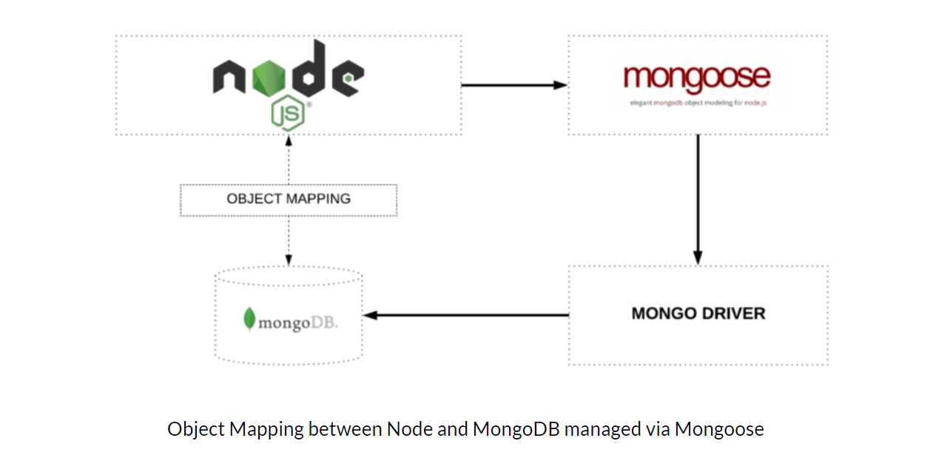

MongoDB is a popular NoSQL database program that stores data in JSON-like documents. Unlike relational databases, it offers flexibility in data structure and is a good choice for storing frequently changing or unpredictable data. It's known for its ease of use, scalability, and developer-friendly features.

NoSQL Database: Facilitates flexible and scalable data storage.

Document-Oriented: Allows for the storage of complex data structures in a single document.

**Express.js:**

Express.js is a **lightweight, flexible web framework for Node.js**. Imagine it as a toolbox that simplifies building web applications and APIs efficiently using JavaScript on the server-side. It streamlines tasks with features like middleware for handling common functions (authentication, logging) and routing for directing requests to the appropriate code. Express is popular for its speed, minimalism, and ease of use, making it a great choice for building various web applications.

Web Framework for Node.js: Simplifies the development of web applications.

Middleware Support: Enhances functionality with reusable middleware components.

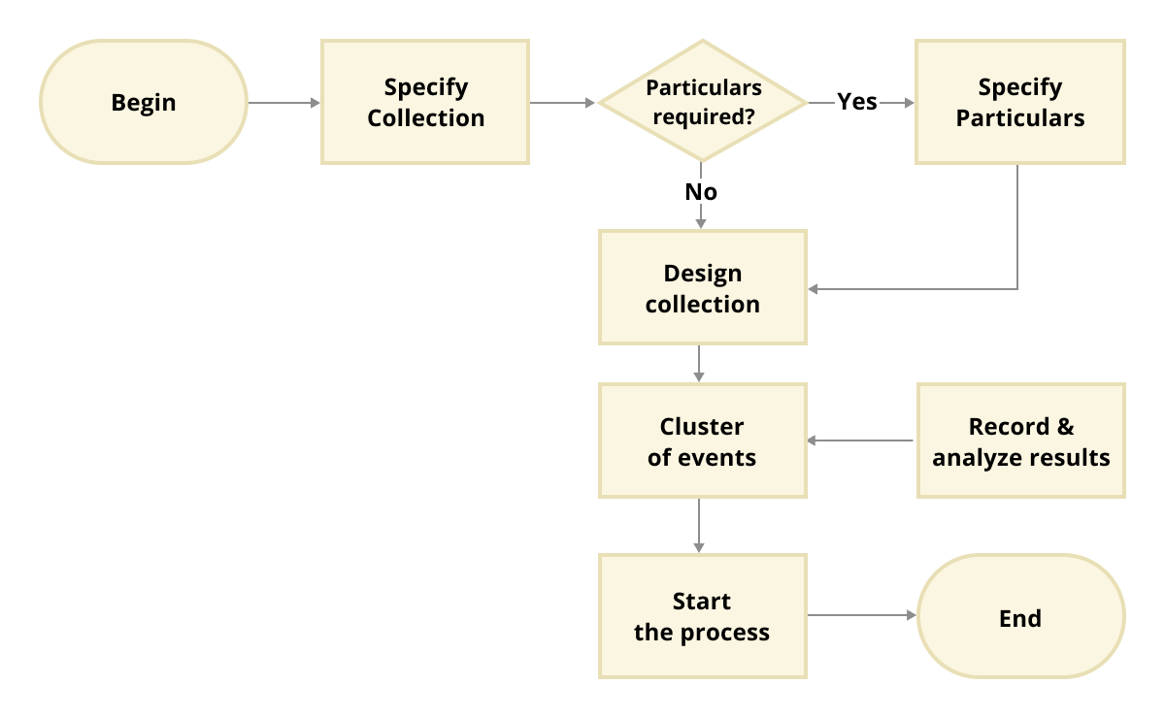**React:**

React.js, or simply React, is a free and open-source JavaScript library for building user interfaces (UIs). It emphasizes a component-based approach, where complex UIs are broken down into smaller, reusable pieces called components.

Front-End Library: Enables the development of dynamic and interactive user interfaces.

Component-Based Architecture: Promotes reusability and maintainability of UI components.

**Node.js:**

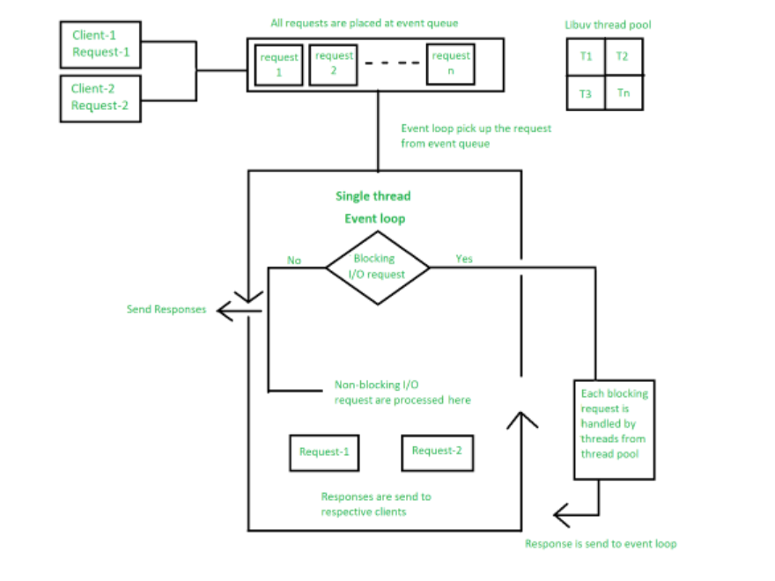

Node.js is an open-source, cross-platform JavaScript runtime environment that lets you run JavaScript code outside of a web browser. This means you can use JavaScript to build server-side applications and tools, not just websites.

Server Environment: Executes JavaScript code server-side, facilitating efficient and scalable back-end development.

Asynchronous Processing: Enhances performance by handling multiple requests concurrently.

Justification for Using the MERN Stack:

Full-Stack JavaScript: Enables seamless development from front-end to back-end using a single programming language.

Scalability: Suited for building scalable applications that can handle a growing number of users and data.

Community and Ecosystem: Supported by a large and active community, providing numerous libraries and tools to enhance development.

Integration of Technologies:

UI Frameworks: While React is a popular choice in MERN, you can integrate other front-end frameworks like Angular or Vue.js for building complex user interfaces.

CSS Libraries: Enhance your app's look and feel with CSS libraries like Bootstrap or Material-UI. These provide pre-built components and styles.

Third-party Libraries: Numerous JavaScript libraries exist for various functionalities like charting (Chart.js), animations (GreenSock), or form validation (Formik).

APIs: Facilitate communication between the front-end and back-end.

Responsive Design: Ensures accessibility across various devices and screen sizes.

Real-Time Features: Supports features like real-time vote updates and notifications.

By leveraging these technologies, the online voting system aims to provide a secure, efficient, and user-friendly platform that addresses the limitations of traditional voting systems and enhances the overall voting experience.

CHAPTER 3 SYSTEM REQUIREMENTS

## 3.1 Functional Requirements

Functional requirements describe the specific behaviours and functions of the online voting system. These include the essential features and capabilities the system must provide to meet user needs.

User Authentication and Authorization:

Users must be able to register and create an account.

Users must log in with their credentials to access the system.

The system must support role-based access control, distinguishing between voters, administrators, and other roles.

Voting Process:

Users must be able to view available elections and their respective details.

Users must cast a vote in an election.

Votes must be securely stored and accurately counted.

Users should receive confirmation of their vote.

Election Management:

Administrators must be able to create and manage elections.

Administrators must manage voter lists, including adding and removing voters.

Administrators must be able to monitor election progress and results.

Result Management:

The system must tally votes and display results to users.

Election results should be accessible in real-time or after the election ends.

User Profile Management:

Users must be able to view and update their profile information.

Users should be able to change their password.

Notification System:

The system must notify users of important events such as upcoming elections, successful vote casting, and results announcements.

Data Export:

Administrators must be able to export election results and voter data for reporting purposes.

## 3.2 Non-Functional Requirements

Non-functional requirements define the system's operational attributes such as performance, security, usability, and reliability.

Performance:

The system must handle up to 1000 concurrent users without significant performance degradation.

Average response time for user actions should not exceed 300ms under normal load conditions.

Scalability:

The system should be able to scale horizontally to accommodate an increasing number of users and elections.

Security:

The system must use HTTPS to secure all data transmissions.

User passwords must be stored securely using hashing algorithms like bcrypt.

Sensitive data, including votes, must be encrypted at rest and in transit.

The system must implement protection against common vulnerabilities such as SQL injection, XSS, and CSRF.

Usability:

The user interface should be intuitive and accessible, requiring minimal training for new users.

The system must provide clear instructions and feedback to users throughout the voting process.

Reliability:

The system must ensure high availability with minimal downtime, ideally achieving 99.9% uptime.

Data integrity must be maintained, ensuring no votes are lost or corrupted.

Maintainability:

The system should be easy to maintain and update, with clear documentation for developers.

Code should be modular and adhere to best practices to facilitate future enhancements and debugging.

Compatibility:

The system should be compatible with major web browsers (Chrome, Firefox, Safari, Edge).

The system should support access from desktop and mobile devices.

## 3.3 User Requirements

User requirements focus on the needs and expectations of different user roles within the system.

Voters:

Voters should be able to easily register, log in, and cast their votes.

Voters need access to information about upcoming elections and their results.

Voters should receive timely notifications about important events.

Administrators:

Administrators should manage user roles and permissions.

Administrators need tools to create and manage elections efficiently.

Administrators require access to detailed reports and data export functionalities.

Developers/Maintainers:

Developers need clear documentation and a well-structured codebase for maintenance and updates.

The system should include error logging and monitoring tools to aid in troubleshooting.

## 3.4 System Constraints

System constraints define the limitations and conditions that the system must operate within.

Regulatory Compliance:

The system must comply with relevant legal and regulatory requirements for online voting and data protection.

Technology Constraints:

The system must be built using the MERN stack (MongoDB, Express.js, React, Node.js).

Budget and Resources:

Development and maintenance of the system must stay within the allocated budget and resource constraints.

Time Constraints:

The system must be developed and deployed within the project timeline to ensure it is ready for the next scheduled election.

Environmental Constraints:

The system should be hosted on reliable cloud infrastructure to ensure high availability and scalability.

The system must be capable of operating across different regions with varying internet speeds and access conditions.

The online voting system must provide robust user authentication, including registration and role-based access control, and ensure secure, accurate vote casting and storage. Administrators need tools to manage elections, voter lists, and monitor progress, while users should be able to view, update profiles, and receive notifications about election-related events. The system should support up to 1000 concurrent users, ensure high availability, secure sensitive data, and be compatible with major web browsers and devices. Built using the MERN stack, it must comply with relevant regulations, be easy to maintain, and stay within budget and time constraints, hosted on reliable cloud infrastructure for global accessibility.

## 3.5 Software Requirements:

Operating System: Windows , Linux, Mac

Languages: Node.js, HTML, CSS, Java Script

Database: MongoDB server, Mongoose

Tools: Visual Studio Code, XAMPP

Browser: All compatable browsers

Hardware Requirements:

Processor: core i3 or higher

RAM:2GB Hard disk:25GB

CHAPTER 4 SYSTEM DESIGN

## 4.1 Architecture Design

The architecture of the online voting system is designed to ensure scalability, security, and ease of maintenance. The system follows a modular design, leveraging the MERN stack, which includes MongoDB for the database, Express.js for the backend framework, React for the front-end library, and Node.js for the server environment.

**4.1.1 System Architecture Diagram**

The system architecture is a multi-tier architecture consisting of:

Client-Side (Front-End): The user interface, built with React, allows users to interact with the system. It includes components for voting, viewing results, and administrative tasks.

Server-Side (Back-End): The server, built with Node.js and Express.js, handles API requests, business logic, and communication with the database.

Database Layer: MongoDB is used to store user data, votes, election information, and results. It is a NoSQL database, which provides flexibility in data storage and scalability.

Security Layer: Security measures include authentication, authorization, data encryption, and secure communication protocols.

The database design focuses on storing data efficiently and securely. MongoDB, being a NoSQL database, allows for flexible schema design, which is ideal for storing varying types of data related to elections, votes, and users.

## 4.2 Database Design

The database design focuses on storing data efficiently and securely. MongoDB, being a NoSQL database, allows for flexible schema design, which is ideal for storing varying types of data related to elections, votes, and users.

**4.2.1 ER Diagrams**

Entities:

* User: Represents the voters and administrators.
* Attributes: userID, username, password, email, role (voter/admin), createdAt
* Election: Represents the elections being held.
* Attributes: electionID, title, description, startDate, endDate, status
* Vote: Represents the votes cast by users.
* Attributes: voteID, userID, electionID, candidateID, timestamp
* Candidate: Represents the candidates participating in elections.
* Attributes: candidateID, electionID, name, party, details

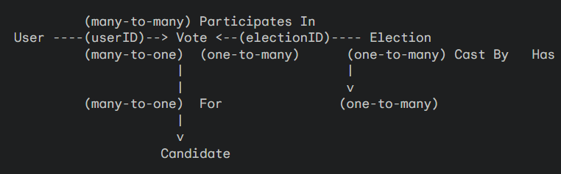

**4.2.2 Schema Design**

1. User Schema: Defines the structure for storing user information, including authentication details.
2. Election Schema: Defines the structure for storing election details.
3. Vote Schema: Defines the structure for storing votes with references to user and election.
4. Candidate Schema: Defines the structure for storing candidate information.

## 4.3 User Interface Design

The user interface (UI) design focuses on providing an intuitive and accessible experience for users. The design follows modern UI/UX principles to ensure ease of use.

**4.3.1 Wireframes and Mockups**

* Home Page: Displays general information about the voting system and upcoming elections.
* Login and Signup Pages: Allow users to register and log in securely.
* Dashboard: Provides access to different functionalities based on user roles (voter/admin).
* Voting Page: Allows users to cast their votes securely.
* Results Page: Displays real-time election results.
* Admin Pages: Provide functionalities for managing elections, users, and monitoring the system.

**4.3.2 Accessibility**

The UI is designed to be accessible to all users, including those with disabilities. Features such as keyboard navigation, screen reader support, and high-contrast modes are implemented.

**4.4 Security Design**

Security is a critical aspect of the online voting system. The design includes multiple layers of security to protect user data and ensure the integrity of the voting process.

**4.4.1 Authentication and Authorization**

Authentication: Users must log in with valid credentials to access the system. Passwords are hashed and stored securely.

Authorization: Different roles (voter, admin) have specific permissions to access various parts of the system.

**4.4.2 Data Protection**

Encryption: All sensitive data, including votes and user information, is encrypted during storage and transmission.

Secure Communication: The system uses HTTPS to secure all communications between the client and server.

**4.4.3 Vulnerability Assessments**

Regular Audits: The system undergoes regular security audits to identify and fix vulnerabilities.

Penetration Testing: Periodic penetration testing is conducted to ensure the system is robust against potential attacks.

The system design ensures that the online voting platform is secure, scalable, and user-friendly, addressing the key requirements and challenges associated with electronic voting.

Setting Up the Development Environment .

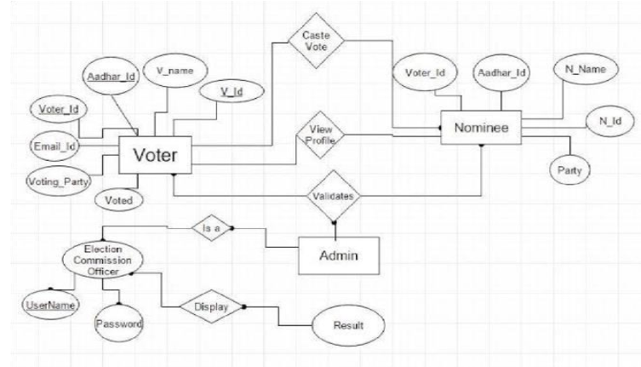

## 4.5 Architecture of Project:

Admin maintains a database to maintain voters data.Voters cast the vote by registering through the website. To reduce the manual work we have built a online voting website for a elections to automate the elections process like generating the results. It works as follows: A new user

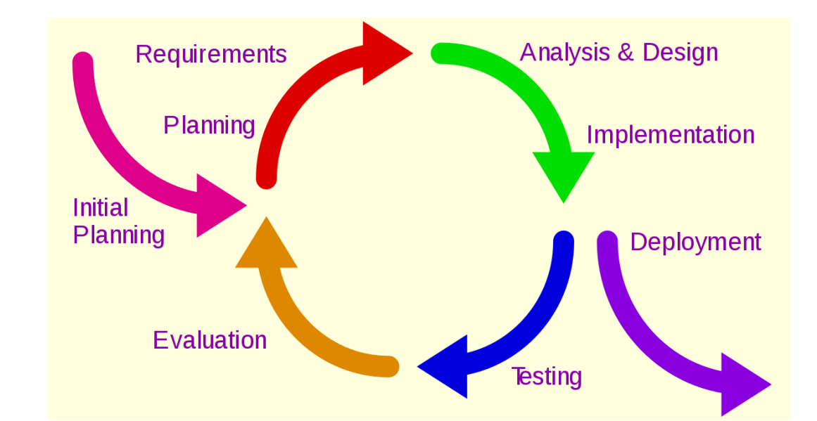

should register to access the services provided by the website. Then the user has to login. Later, user will be verified by sending an OTP to his/her email. If user is a genuine user he will be redirected to the voting page where he can access the services provided by the website. The information given by the user will be stored in the database.so it can be retrieved whenever required. Users can cast the vote online, view the results at any point of time. Once the users are done with their activities they can log out of the website. In this way, their work becomes easier, secure, and save their time.

CHAPTER 5 IMPLEMENTATION

## 5.1 Backend Development

Backend development focuses on creating a robust server-side infrastructure that supports the core functionalities of the online voting system. The backend is developed using Node.js and Express.js.

**5.1.1 Setting up the Environment**

Install Node.js and npm: Ensure Node.js and npm (Node Package Manager) are installed.

Initialize the Project: Create a new project directory and initialize it with npm init.

Install Dependencies: Install necessary packages such as Express.js, Mongoose, bcrypt, JSON Web Token (JWT), and others.

1. **Install Node.js and npm:** Make sure you have Node.js and npm installed. Node.js is the runtime environment, and npm is the package manager for JavaScript. You can find them bundled together at the official Node.js website [Node.js download].
2. **Create a project directory:** Create a new directory for your project. This will keep your project files organized.
3. **Initialize the project:** Navigate to your project directory in your terminal and run npm init. This initializes a project with a package.json file, which stores information about your project and its dependencies.
4. **Install dependencies:** Use npm install followed by the package name to install necessary tools like Express.js (web framework), Mongoose (ODM for MongoDB), bcrypt (password hashing), and JSON Web Token (JWT) for authentication.

That's it! In four steps, you've set up the environment to develop your Node.js application. Remember, these are just the initial steps. Each step can involve more details depending on your project requirements.

**5.1.2 Creating the Server**

Server Setup:

Create an Express server and configure middleware.

An Express server is the foundation of your web application. To set it up, you'll use the Express.js framework within Node.js. This involves creating an Express instance and defining a port for it to listen on. Middleware functions are like mini-applications that intercept requests and responses, adding functionalities like parsing data, logging requests, or serving static files. You can configure these middleware functions in your server code to enhance security, handle user input, and deliver a smooth user experience.

Javascript

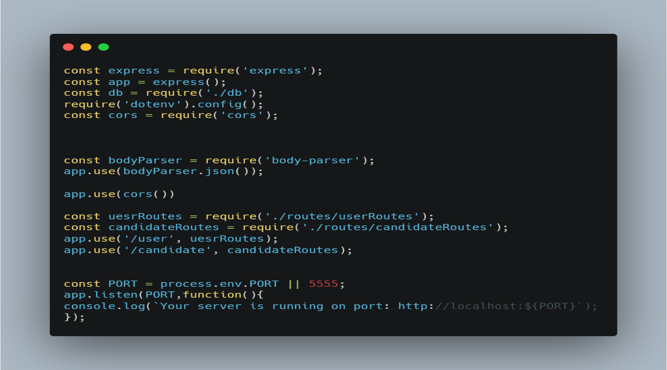

**5.1.3 Database Connection**

MongoDB Connection: Connect to MongoDB using Mongoose.

In a well-structured application, data is stored in a database. This section likely focuses on establishing a connection between your application and MongoDB, a popular NoSQL database. Mongoose acts as a bridge, allowing your application to interact with MongoDB using familiar JavaScript syntax. This connection is crucial for functionalities like user management, storing voting data, and displaying results – essentially, anything that requires saving or retrieving information.

Javascript

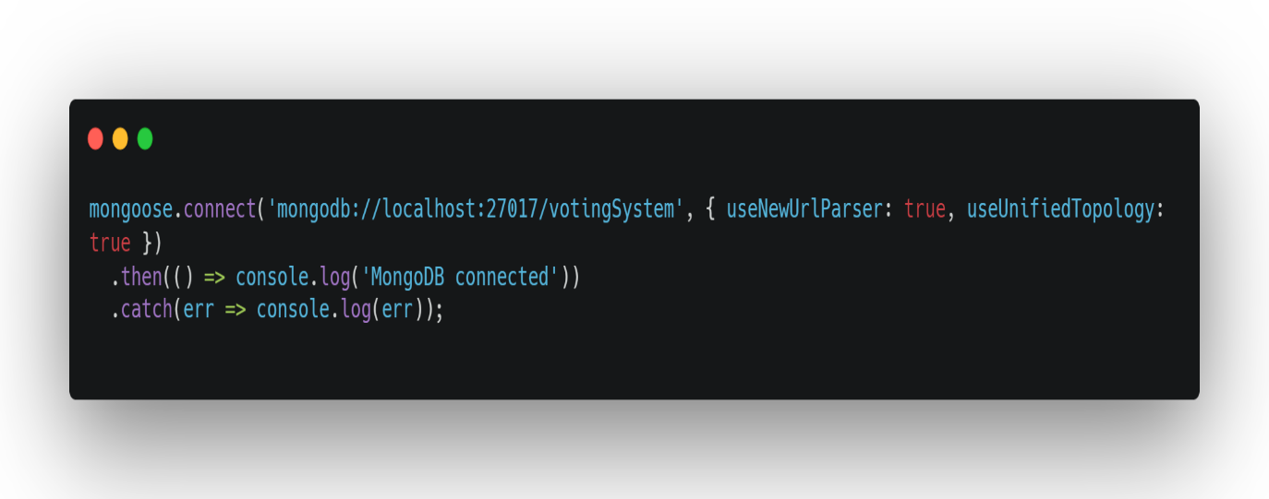

**5.1.4 API Endpoints**

User Authentication: Create routes for user registration, login, and profile management.The API should provide endpoints specifically designed for user authentication. These endpoints would handle functionalities like user registration, login, and profile management. During registration, a new user would create an account by providing credentials and potentially additional information. Login would allow existing users to access the application by verifying their credentials. Profile management endpoints would empower users to view and update their information, potentially including profile pictures, contact details, or notification preferences. These user authentication endpoints are crucial for establishing secure access and personalized experiences within the application.

Javascript

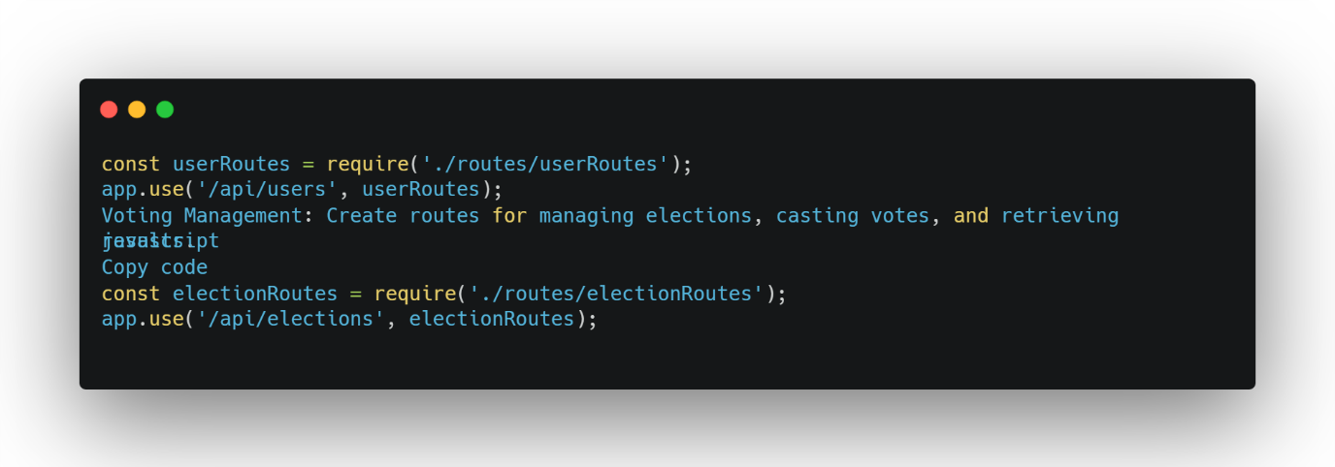

**5.1.5 Security Implementations**

To safeguard user credentials, this system utilizes a two-pronged security approach. Firstly, passwords are never stored directly. Instead, bcrypt, a robust hashing algorithm, transforms them into a unique, uncrackable string. This renders them useless even if a data breach occurs. Secondly, JWT (JSON Web Token) takes center stage for user authentication. JWTs act as secure tokens, granting access to authorized users after successful login. This eliminates the need to constantly transmit passwords and minimizes security risks.

## 5.2 Frontend Development

Frontend development focuses on creating an interactive and responsive user interface using React.

React empowers frontend development by enabling the creation of user interfaces (UI) that are both interactive and responsive. Imagine building the application's facade - the visual elements users interact with. React excels at breaking down this UI into reusable components, like building blocks. These components can dynamically update based on user actions or data changes, making the interface interactive. Furthermore, React ensures the UI adapts seamlessly across different devices (phones, tablets, desktops) for a responsive experience. In essence, React acts as a powerful tool to craft user-friendly and adaptable interfaces for your application.

**5.2.1 Setting up the Environment**

Install React: Use Create React App to bootstrap the frontend project.

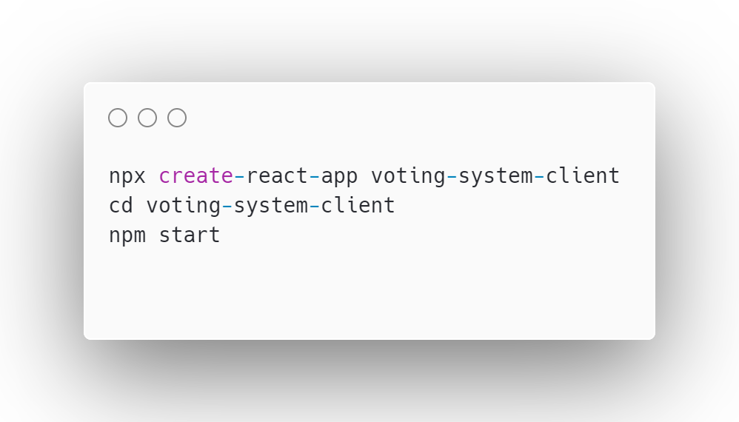

**5.2.2 Component Structure**

Main Components: Create main components such as Home, Login, Signup, Dashboard, Voting, Results, and Profile.

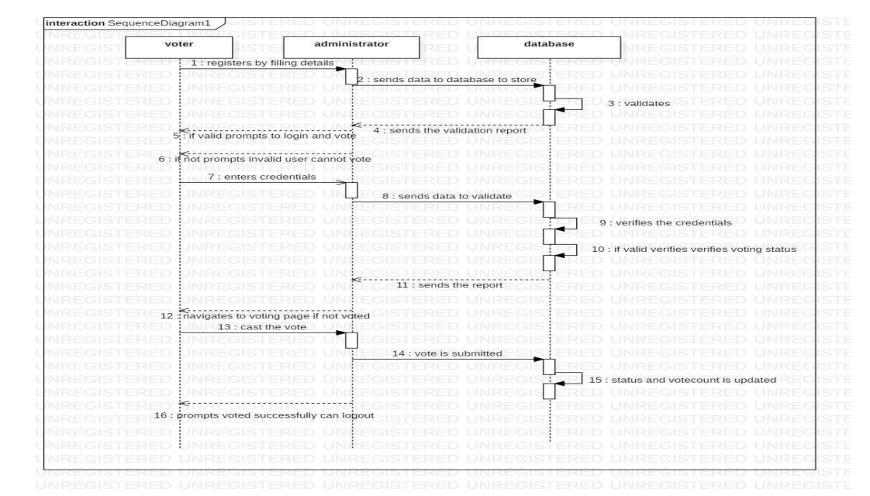A well-structured application relies on key components. The Home page serves as a welcoming hub, while Login and Signup grant access. The Dashboard centralizes user activity and information. Voting is the core functionality, allowing users to participate in choices. Results display the outcome, often with visualizations. Finally, the Profile section empowers users to manage their information and preferences. These components, working together, create a smooth user experience.

**5.2.3 State Management**

React Hooks: Use React Hooks (useState, useEffect) to manage component state and lifecycle.

Context API: Implement Context API for global state management, particularly for user authentication status.

This application will leverage React's Hooks system for state management. Individual components can utilize useState to manage their internal data and trigger updates. Additionally, the useEffect Hook allows components to perform side effects like data fetching after rendering. For global state management, especially regarding user authentication, the Context API will be implemented. This creates a shared context accessible throughout the component tree, eliminating the need to pass authentication data down through every level. This keeps components clean and simplifies state management for critical application-wide information like login status.

**5.2.4 API Integration**

Axios for HTTP Requests: Use Axios to handle API requests to the backend.

Axios simplifies fetching data from APIs. Unlike traditional methods, Axios uses Promises for asynchronous communication, making your code cleaner.

With Axios, you define requests in a configuration object, specifying the URL, method (GET, POST, etc.), and any data to send. Axios handles the details and returns a Promise that resolves with the response data or rejects with error information. This allows you to write clear and concise code to interact with your backend APIs.

**Additionally, Axios offers features like:**

* Automatic JSON serialization and deserialization
* Progress tracking for uploads and downloads
* Cancellation of ongoing requests
* Support for uploading files

By leveraging these features, you can build more powerful and user-friendly applications that interact with backend APIs.

Javascript

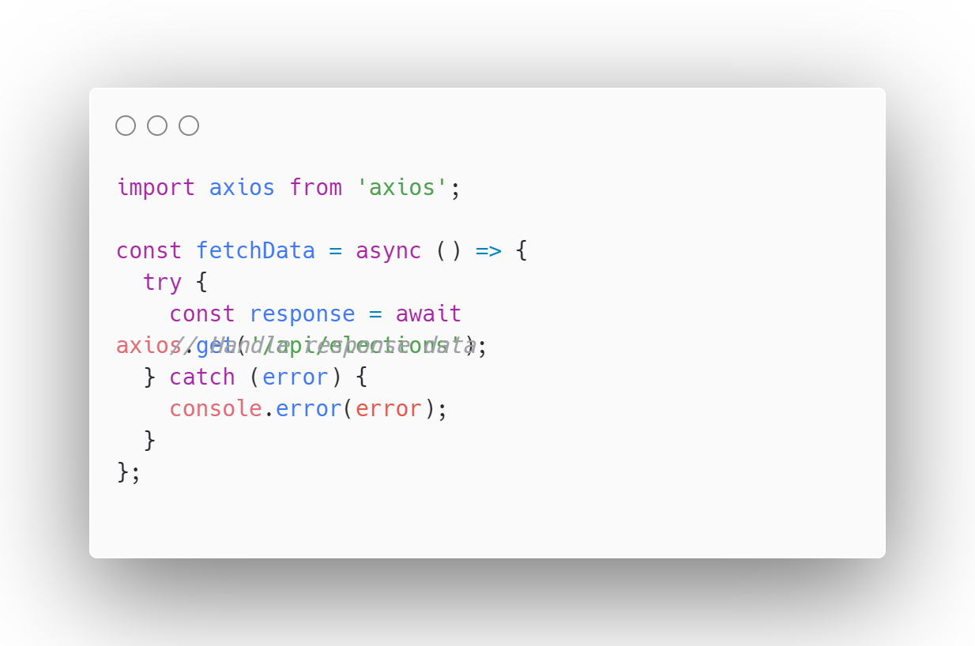

**5.2.5 Routing**

React Router: Implement routing to navigate between different pages of the application.

Additional Features:

* Nested Routes: You can define nested routes for complex navigation structures, allowing you to create hierarchical page layouts.
* Programmatic Navigation: React Router provides hooks like useNavigate for programmatic navigation triggered by events or logic within your components.
* Params: Routes can capture dynamic parts of the URL as parameters, allowing you to pass data between components.

Javascript

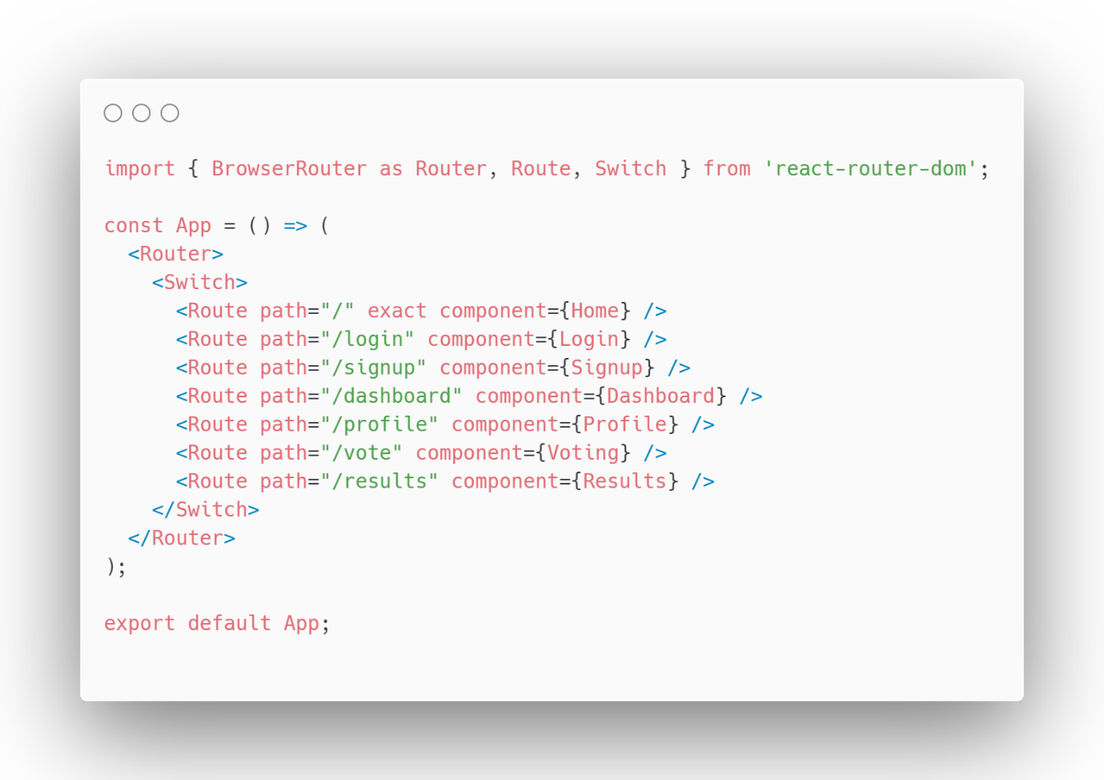

## 5.3 Integration of Components

Integration involves connecting the backend APIs with the frontend components to enable seamless data flow and user interaction.

Imagine a restaurant kitchen (backend) and the dining area (frontend) in an app. Integration is like building a waiter system. The backend APIs act as the kitchen staff, preparing data (like

cooking food). The frontend components are the tables and menus where users interact. Here's how it works:

1. Users make requests on the frontend (e.g., order food).
2. The frontend sends these requests through API calls to the backend.
3. Backend APIs retrieve data from databases (like checking ingredients).
4. The backend prepares the data (like cooking) and sends it back.
5. The frontend receives the data (like serving food) and updates the user interface (like showing the order confirmation).

This smooth exchange between backend and frontend, facilitated by APIs, creates a seamless experience. Users interact with the frontend, unaware of the complex backend operations that make it all work.

**5.3.1 Authentication Flow**

Login and Signup: Integrate frontend forms with backend authentication APIs. Handle token storage and user session management.

Building user login involves a two-way street: frontend and backend.

* **Frontend:**
  1. Design forms for signup and login with aadhaar number/password or email/password.
  2. Capture user input and send it securely (HTTPS) to backend APIs for validation.
  3. Upon successful login, the frontend receives a token (e.g., JWT) from the backend.
* **Backend:**
  1. APIs handle user registration and login requests.
  2. It verifies credentials against a user database and generates a token if valid.
  3. APIs can use secure techniques like hashing passwords for storage.
* **Token & Session:**
  1. The token is stored securely on the frontend (e.g., HttpOnly cookie, sessionStorage with limitations).
  2. With each request to protected resources, the frontend sends the token in the header for authorization.
  3. The backend validates the token and grants access if legitimate, maintaining user session.

This secure flow allows you to manage user access and build robust authenticated applications.

**5.3.2 Voting Process**

Voting Interface: Connect the voting component to the backend API to fetch election details and submit votes.

Here's how to connect your voting component to a backend :

1. **Fetching Election Details:**
   * The voting component triggers a function to call the API's "Get Election Details" endpoint.
   * This endpoint should return data like candidate names, positions, and potentially additional information.
   * The component receives the data and populates the voting interface (e.g., displaying candidate names).
2. **Submitting Votes:**
   * When the user selects a candidate, the component calls the API's "Submit Vote" endpoint.
   * This endpoint expects data like the user ID (authenticated) and the selected candidate ID.
   * The API validates the vote (e.g., checking user eligibility) and stores it.
   * The component receives a confirmation message (success/error) to update the user interface.

**Security Note:**

* Ensure the API uses HTTPS for secure communication and proper authentication to prevent unauthorized voting.

**5.3.3 Results Display**

Real-Time Results: Implement real-time results fetching and display using polling or WebSocket connections.

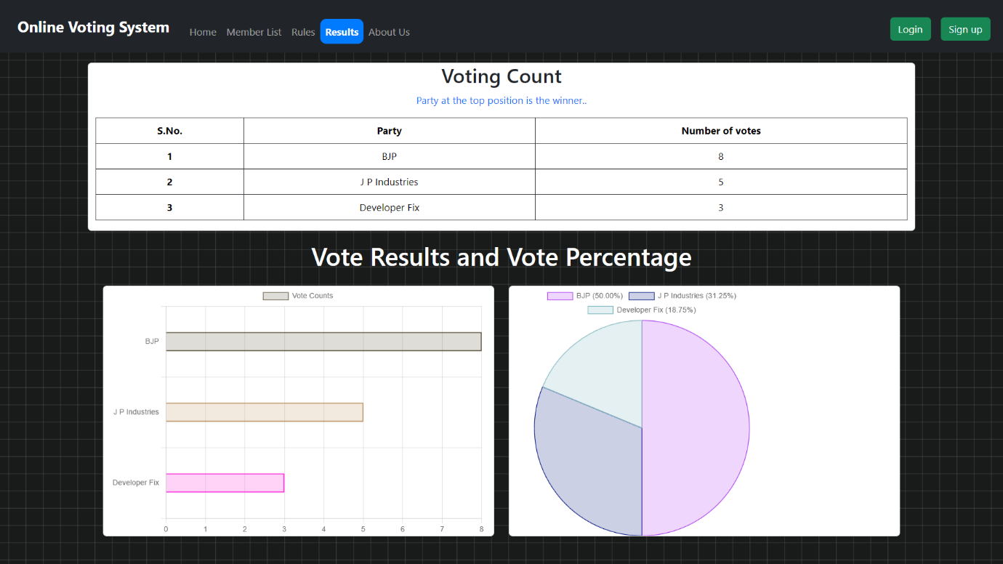

## 5.4 Deployment

Deploying the application involves setting up production environments, configuring servers, and ensuring that the application is accessible to users.

**5.4.1 Deployment Strategies**

Containerization: Use Docker to containerize the application for consistent deployment environments.

Cloud Platforms: Deploy the backend on platforms like Heroku, and the frontend on platforms like Render, Vercel or Netlify.

**5.4.2 Steps for Deployment**

Build the Frontend: Create a production build of the React application.

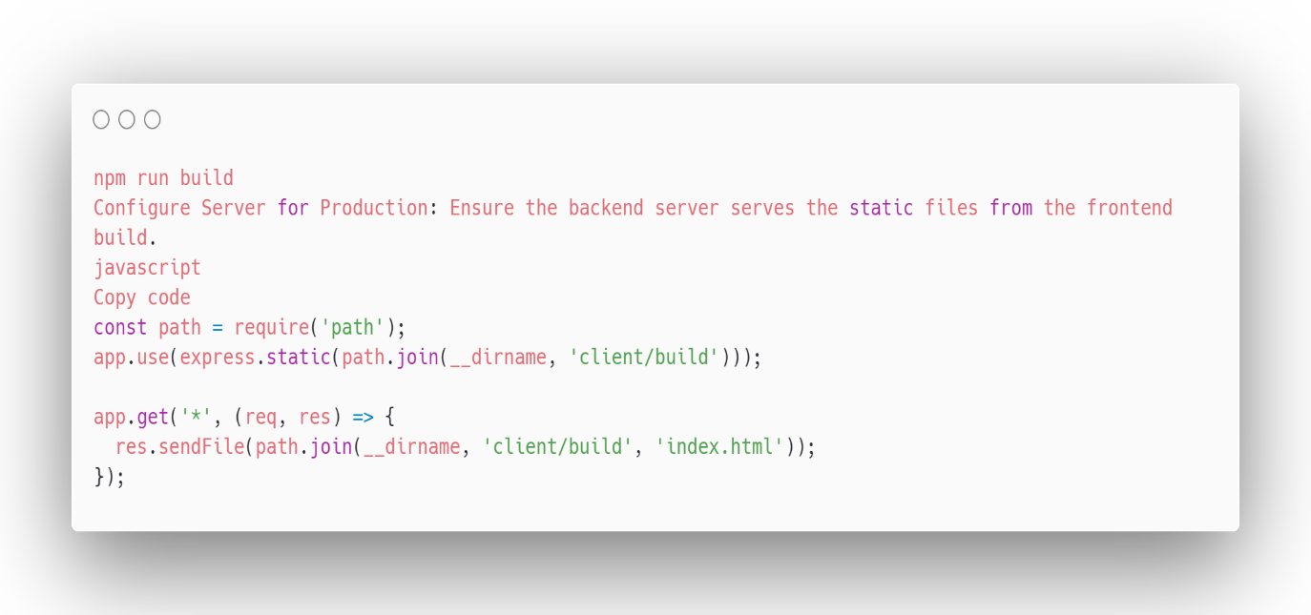

Deploy to Cloud Platforms: Push the code to the respective cloud platforms and configure environment variables.

**5.4.3 Tools and Platforms Used**

Backend Deployment: Render or Heroku.

Database: MongoDB Atlas for cloud-based database management.

Frontend Deployment: Vercel or Netlify for static site hosting.

This implementation section provides a detailed walkthrough of the development and deployment process for the online voting system, ensuring all components work together seamlessly to deliver a functional and secure application.

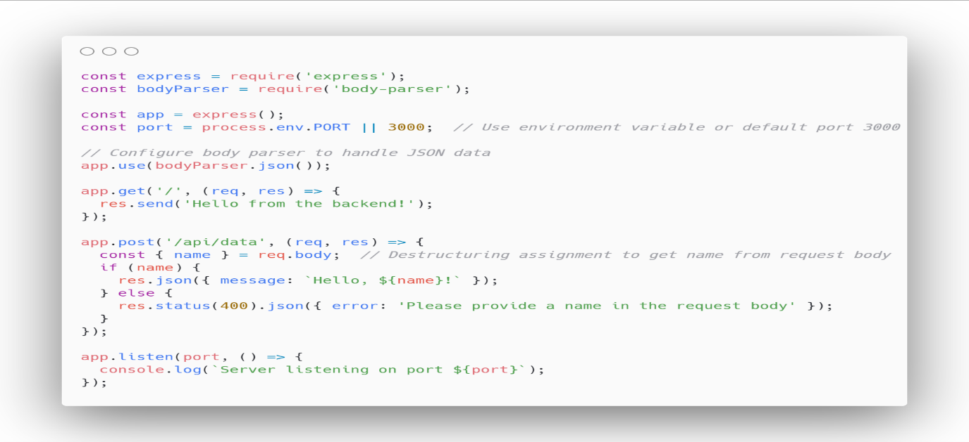

CHAPTER 6 PROJECT SHOWCASE

## 6.1 Front Interface

**Upon launch, the application presents a navigation bar at the top of the screen. This navbar offers two primary functionalities:**

* **Authentication:**
  + **Login Button:** This button allows existing users to sign in with their credentials and access the full features of the application.
  + **Signup Button:** This button guides new users through a registration process to create an account and begin using the application.
* **Navigation:**
  + **Home:** This section likely serves as the application's landing page, providing an overview or central hub for users.
  + **About:** This section presumably offers information about the application itself, its purpose, creators, or any other relevant details.
  + **Rules:** This section might explain the guidelines or regulations users must adhere to while interacting with the application.
  + **Results:** This section could potentially display outcomes, scores, achievements, or other relevant data based on user actions within the application.

**Visual Design:**

* **Navbar:** Imagine a horizontal bar positioned at the top of the screen. It could have a solid background color or a subtle gradient. The text labels for buttons and sections might be displayed in a contrasting color for better readability.
* **Buttons:** Both "Login" and "Signup" buttons can be designed for clarity. Consider using icons like a lock for login and a user silhouette for signup. These buttons could be rounded or have a slight border for a polished look.
* **Navigation Links:** "Home," "About," "Rules," and "Results" can be displayed as text links or styled buttons within the navbar. Maintain consistency in style with the login and signup buttons.

**User Interaction:**

* **Login Button:** Clicking the login button might trigger a pop-up window or redirect the user to a dedicated login page where they can enter their username and password.
* **Signup Button:** Clicking the signup button could lead to a registration form where users provide their details to create an account. This form might ask for information like name, email address, and a chosen password.
* **Navigation Links:** Clicking on these links would likely switch the content displayed on the main screen.
  + Home: Clicking "Home" could bring the user back to the application's main landing page, offering a quick way to return to the central hub.
  + About: Selecting "About" might display a page with details about the application's purpose, functionalities, team behind it, or any relevant information for users to understand the app better.
  + Rules: Clicking on "Rules" could showcase the regulations or guidelines users need to follow while using the application. This section might outline acceptable behavior, content restrictions, or other important policies.
  + Results: Selecting "Results" could potentially display user-specific information based on their actions within the application. This section might showcase scores achieved, completed tasks, or other relevant data depending on the application's purpose.

**Additional Considerations:**

* **Responsiveness:** The application's layout should ideally adapt to different screen sizes (desktop, mobile, tablets) to ensure a seamless user experience across devices. The navbar elements might need to rearrange or stack vertically on smaller screens for optimal viewing.
* **Accessibility:** Consider incorporating features like alternative text descriptions for icons and ensuring adequate color contrast for visually impaired users.

By elaborating on these aspects, you get a clearer picture of how the initial application view might function and appear to the user.

Before Login:

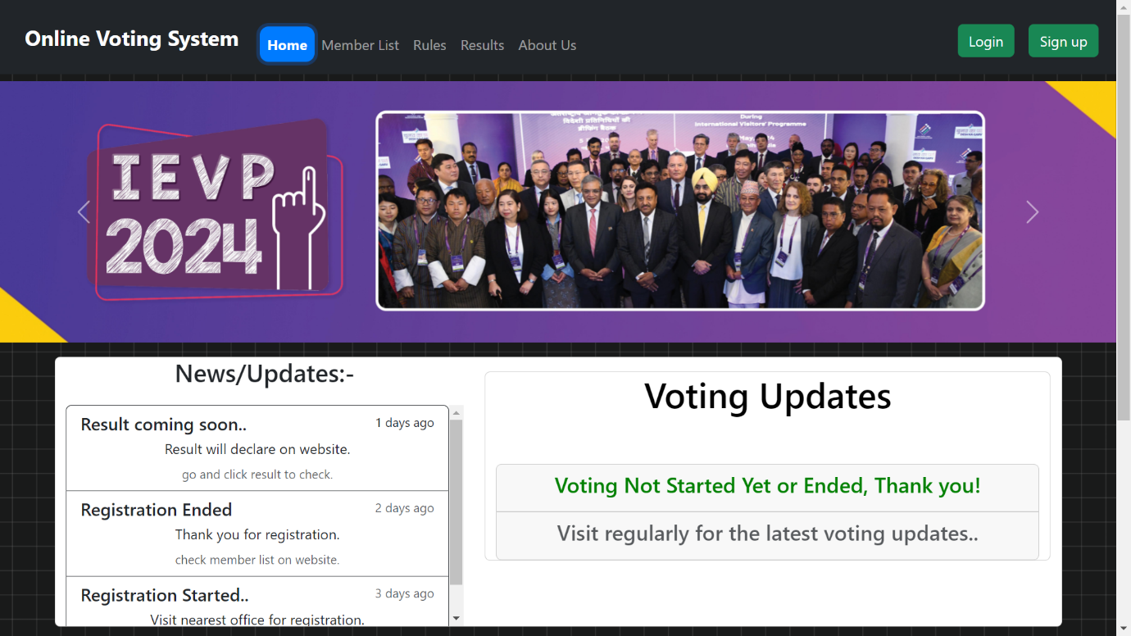

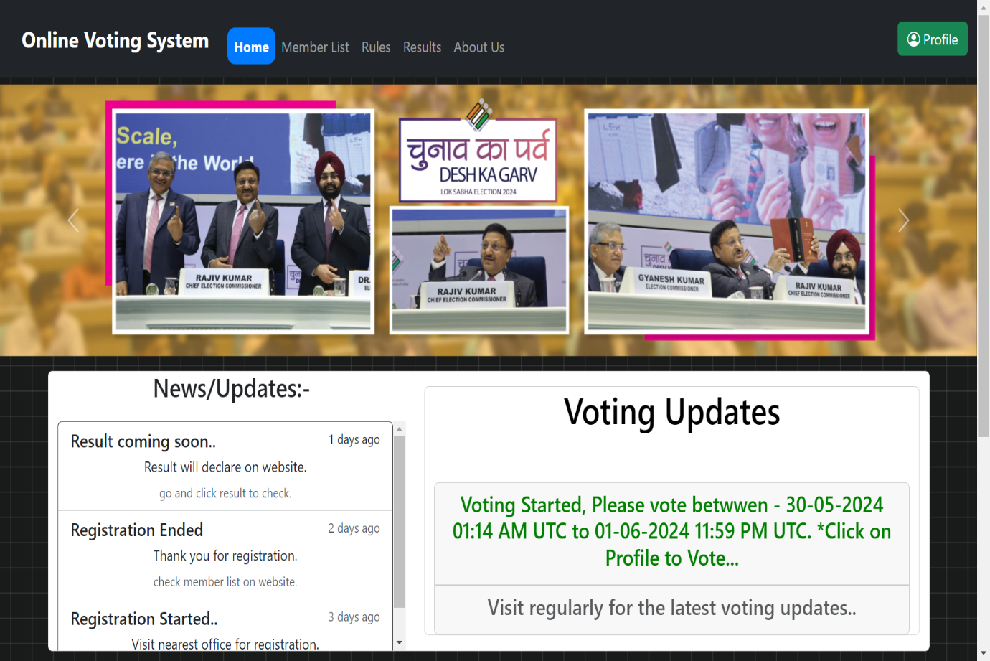After Login:

## 6.2 Instruction section

Below news/updates section we have a **How to use online voting system?** Where we give three types of instructions

1. Registration Instruction

2. Voting Instruction

3.Login Instruction

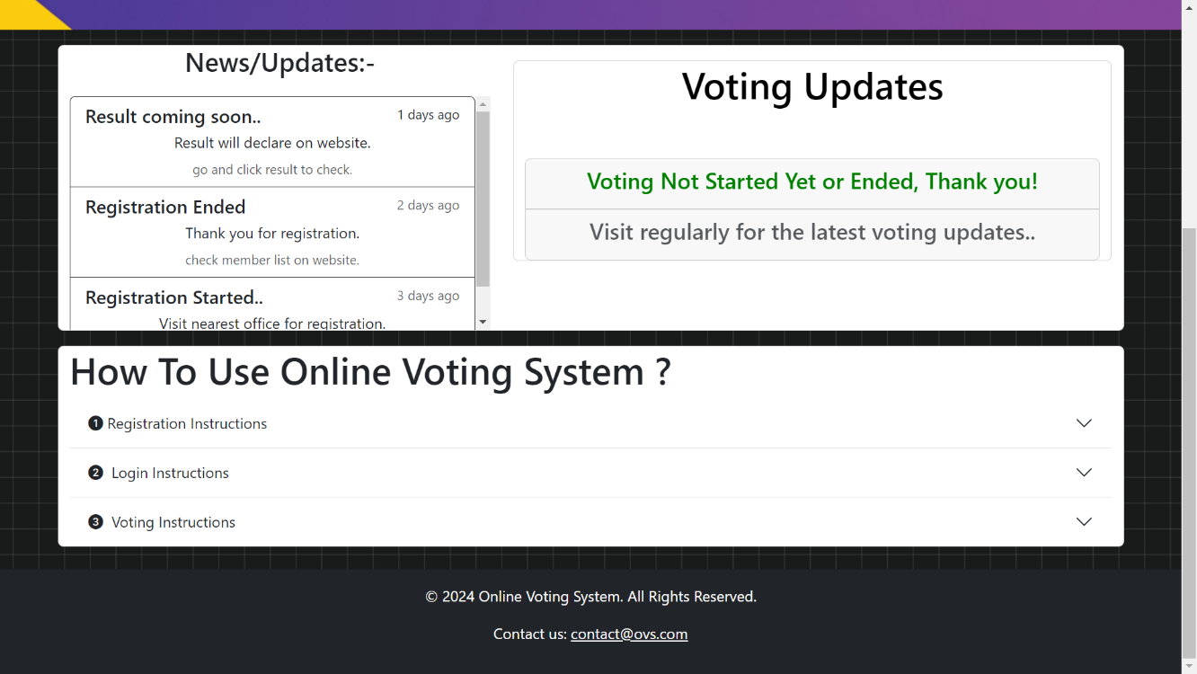

## 6.3 Secure Registration for New Applicants

This portal enables secure registration for new applicants only. To register for the application, you'll need to provide the following information:

* **Demographic Details:**
  + Full Name
  + Aadhaar Number(Mandatory)
  + Full Address
  + Email Address (for communication/ verification)
  + Mobile Number

*All field are required.

* **Authentication Documents:**
  + Aadhaar Card Number (for identity verification)
  + Voter ID (Optional, for additional verification)

**Important Notes:**

* All fields are mandatory unless specified as optional.
* Upon successful registration, you'll be authenticated using the provided details.
* Once authenticated, you'll be registered for the application and will be able to access its features.
* This portal restricts duplicate registrations. If a matching Aadhaar number is found, you'll be prompted to log in with existing credentials instead of registering again.

**Benefits of Secure Registration:**

* Ensures only eligible new applicants can access the application.
* Protects user data through secure authentication processes.
* Simplifies the registration process for new users.
* Enhances security with OTP (One-Time Password) verification.
* Prevents duplicate registrations.
* Facilitates compliance with legal and regulatory requirements
* Builds user trust and confidence.
* Supports recovery and account management features.
* Improves user engagement and retention.
* Allows for secure identity verification.
* Provides a foundation for personalized user experiences.
* Reduces administrative burden.
* Enables better data management and analytics.
* Enhances scalability and future growth.

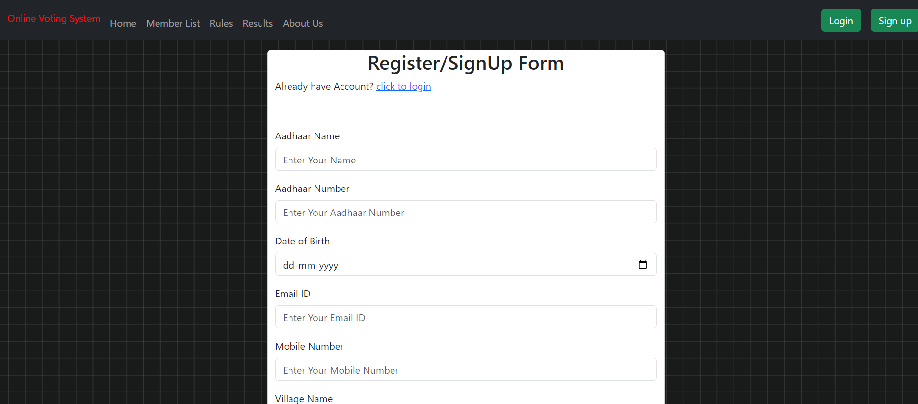

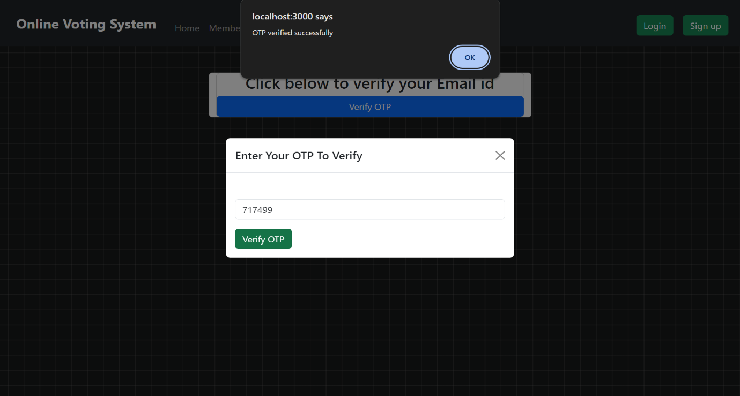Otp Verification:

## 6.4 Voter Login

A login system that relies on two factors for authentication: Aadhaar number and password. Let's break it down further:

**Unique Aadhaar Number:**

* Aadhaar is a unique identification system in India. Each resident is assigned a single, permanent 12-digit Aadhaar number.
* This ensures that only the rightful owner of the Aadhaar number can attempt to log in.

**Password:**

* On top of the Aadhaar number, a password is required. This adds an extra layer of security.
* Even if someone knows your Aadhaar number, they wouldn't be able to log in without the correct password.

**Security Considerations:**

* This system offers two-factor authentication, which is generally more secure than relying on a single factor (like just a password).
* However, it's important to choose a strong, unique password and keep it confidential to maximize security.

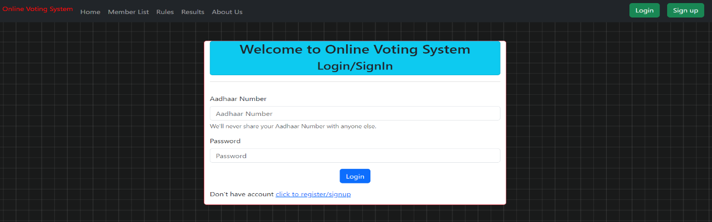

## 6.5 Profile Section

**User Dashboard:**

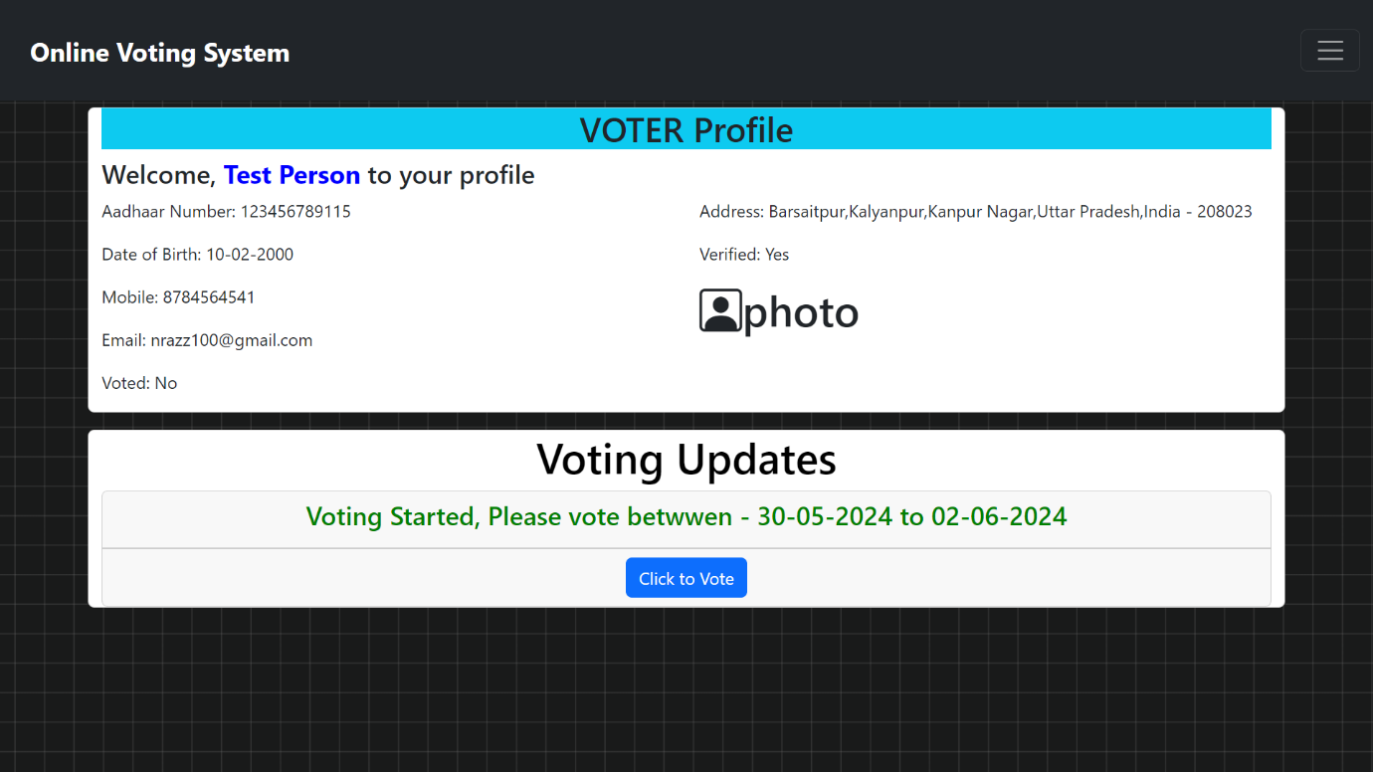

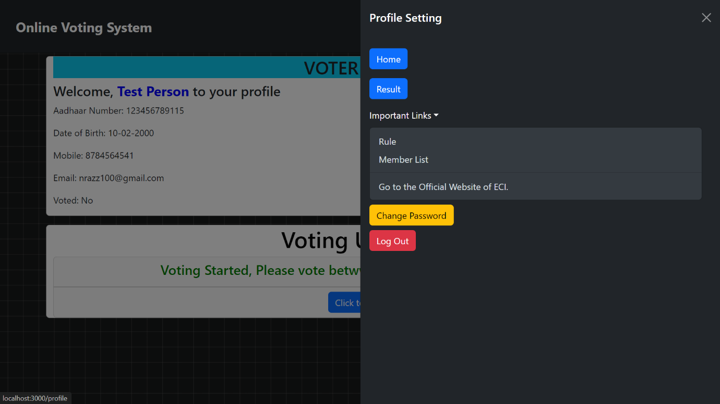

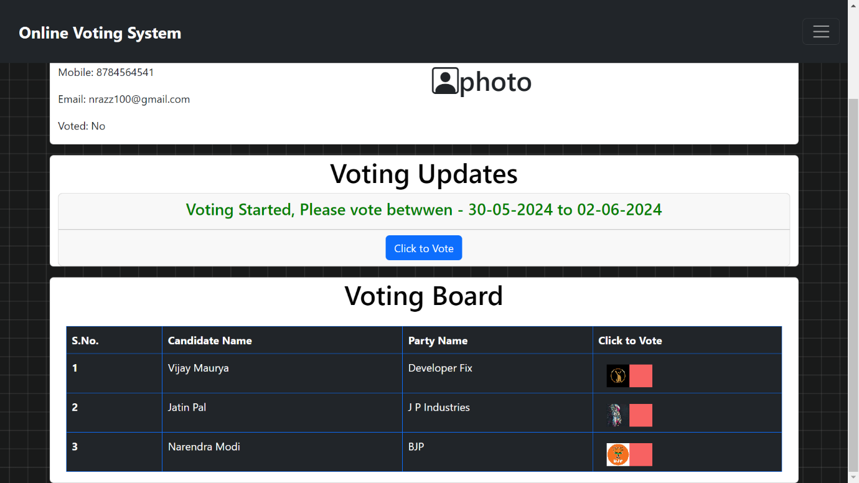

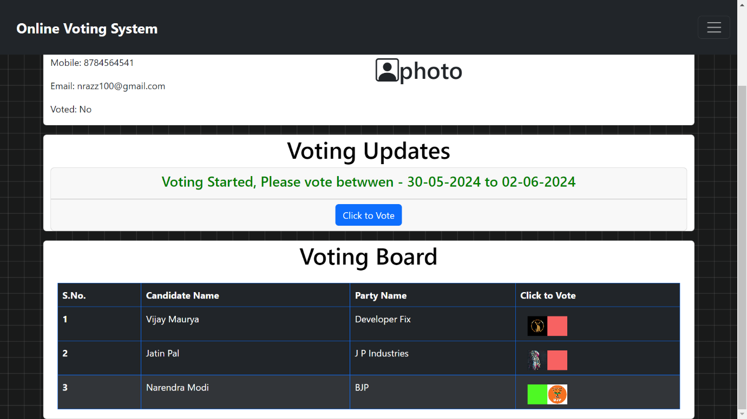

After Click on Vote:

After Successful Vote Capture:

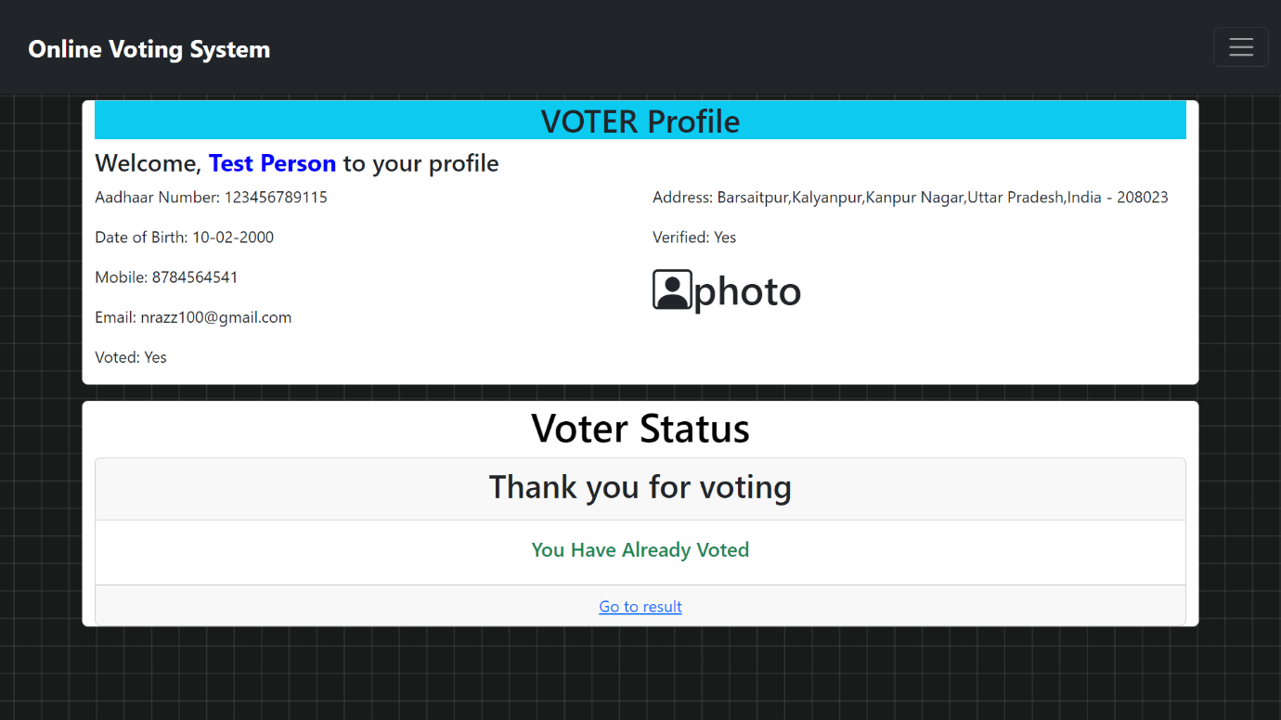

**Admin Dashboard:**

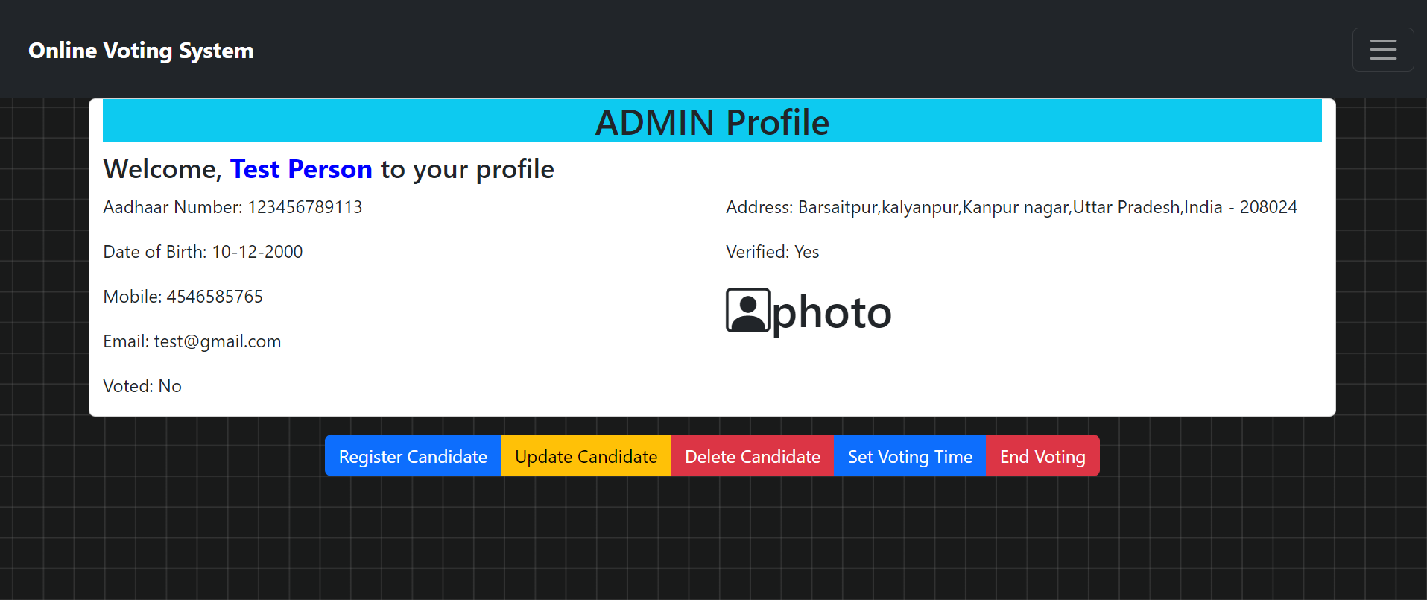

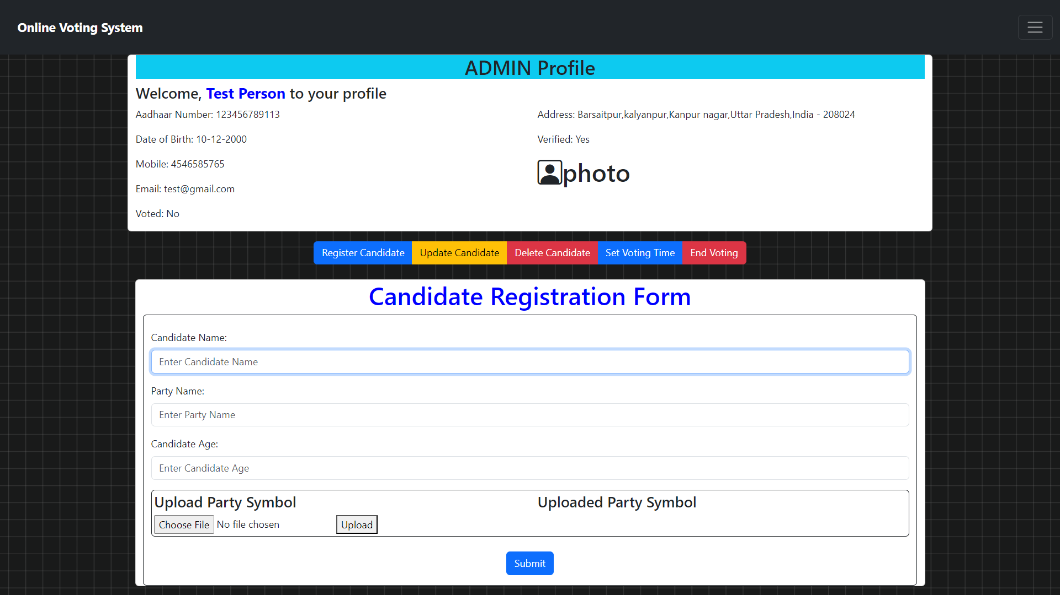

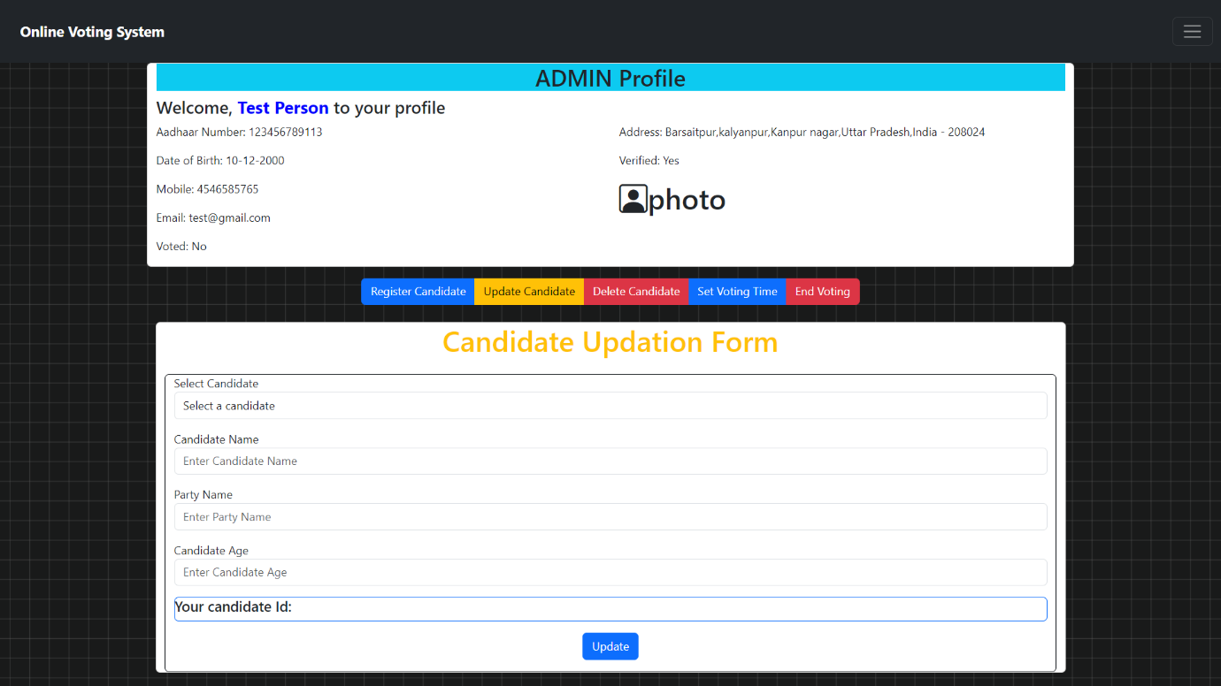

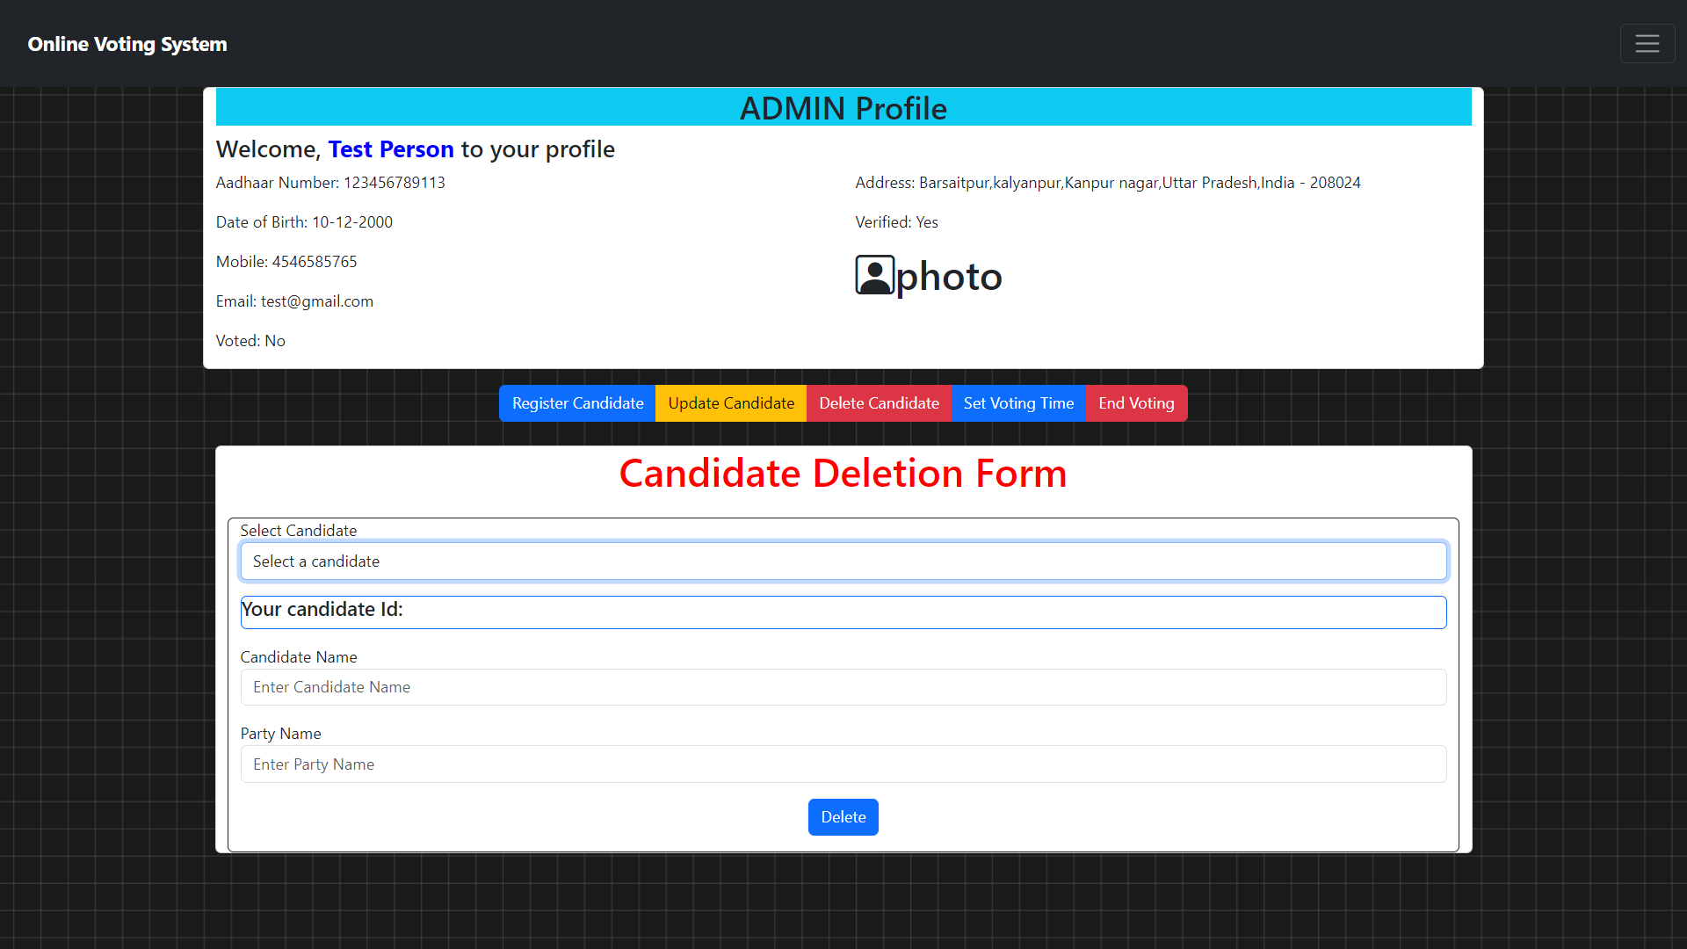

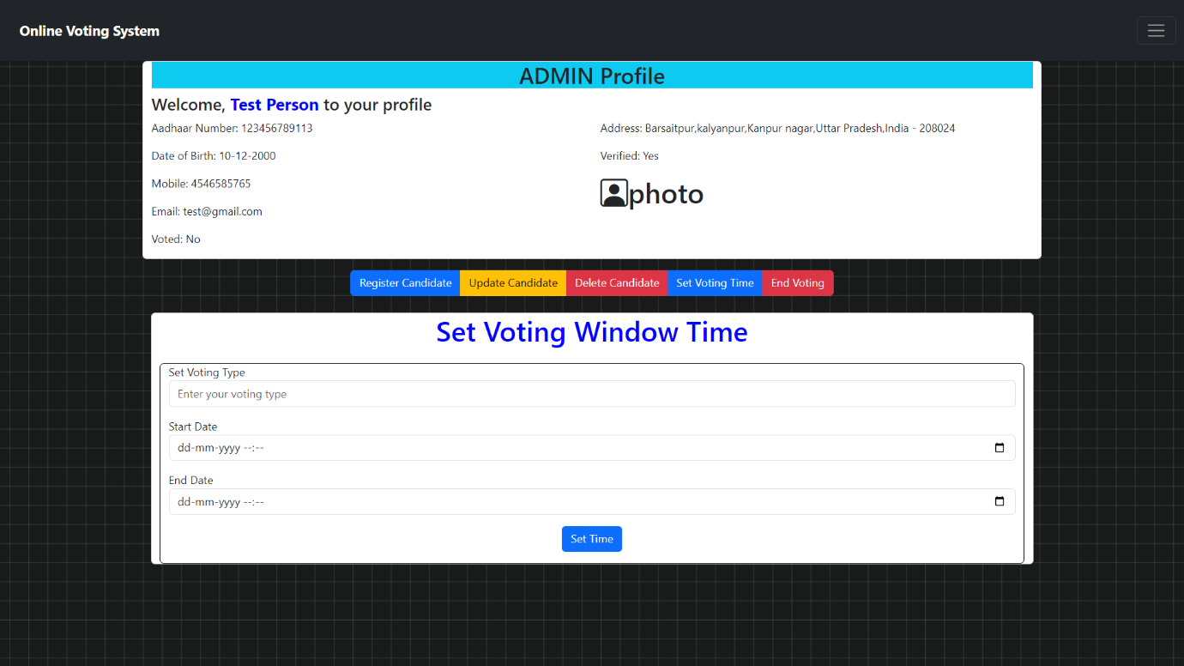

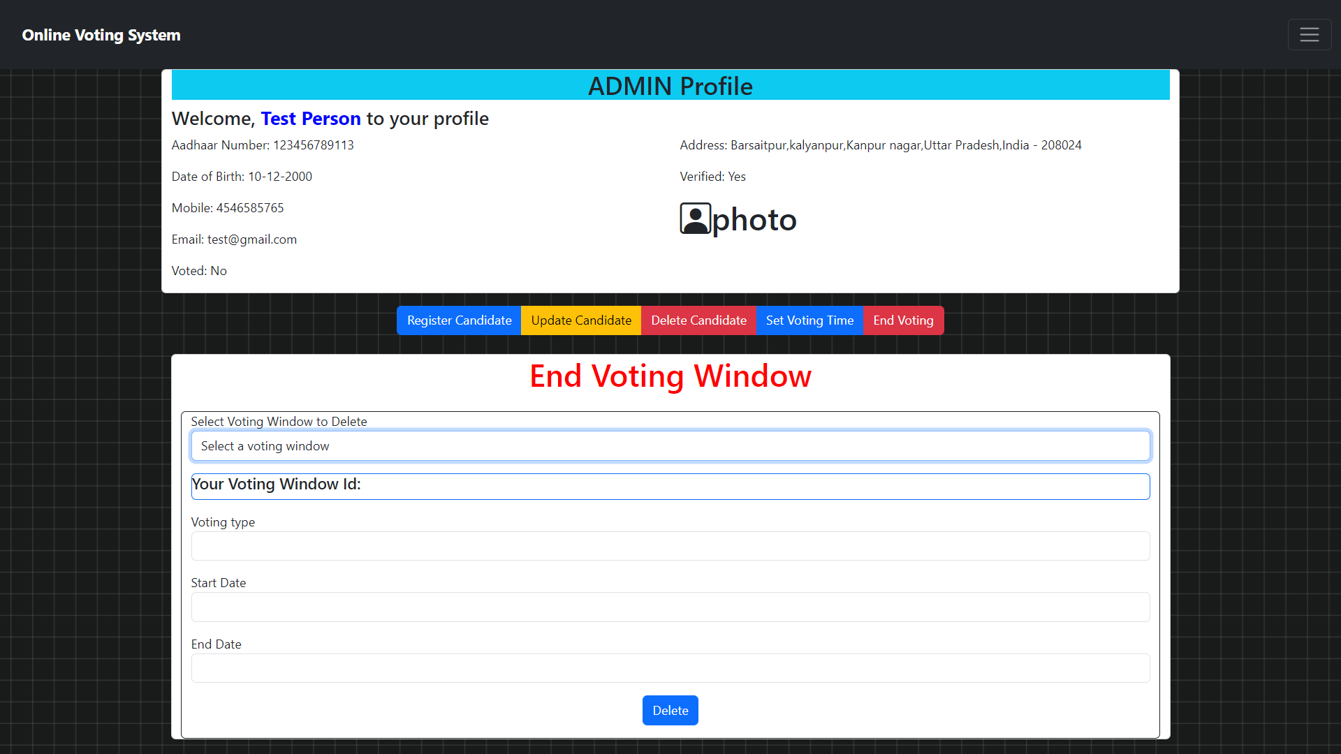

## 6.6 Voting Rules

In navbar we have a section where we defined the rules to vote, and these are being followed by each and every candidates.

Voting Rules :

Every citizen of India who is 18 years of age or older is entitled to vote in elections, subject to certain exceptions and disqualifications specified by law.

To vote in an election, a person must be registered as a voter in the electoral roll of the constituency where they reside.

Upon successful registration, eligible voters are issued a Voter ID Card (EPIC) by the Election Commission.

Each eligible voter is entitled to cast only one vote in an election, irrespective of their social status, wealth, or other factors.

Voting in India is conducted through secret ballot, ensuring the confidentiality of an individual's voting preferences.

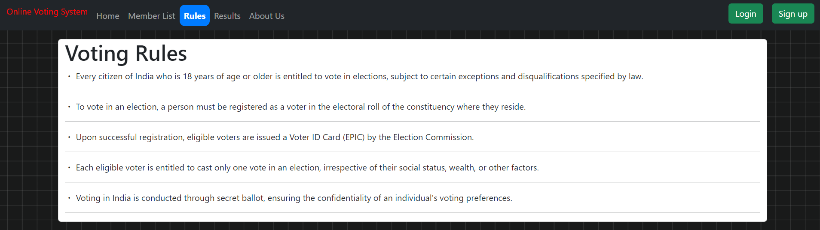

## 6.7 Members (candidate ) List:

Each user will get a candidate list in his/her navbar section in which there will be a list of candidate from which user will have to choose one. And these candidate list changes as per the location

For example , we have taken a dummy members list and in the list we have different candidates or members with their party they belong too and sign of the party.

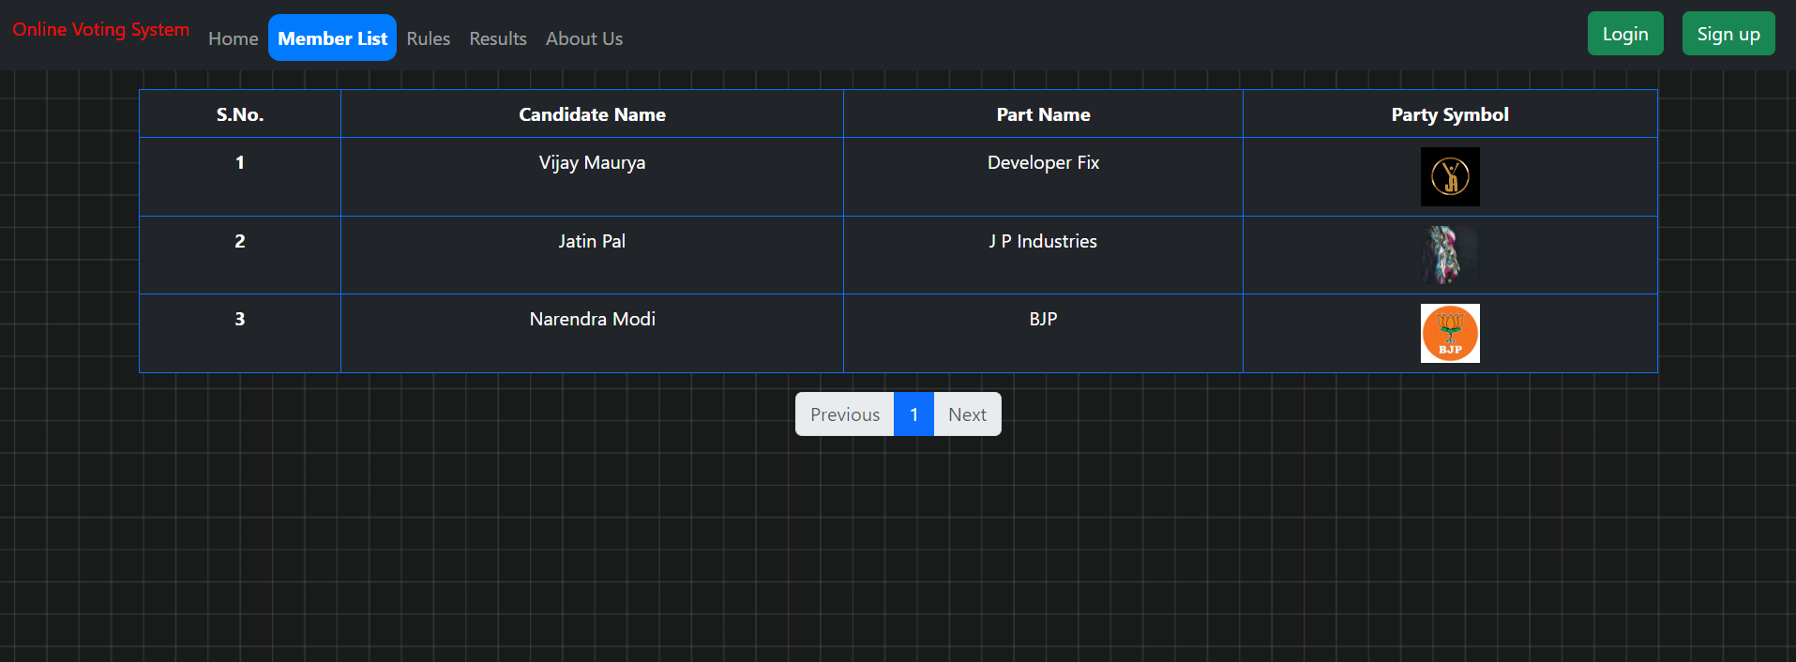

## 6.8 About us Section

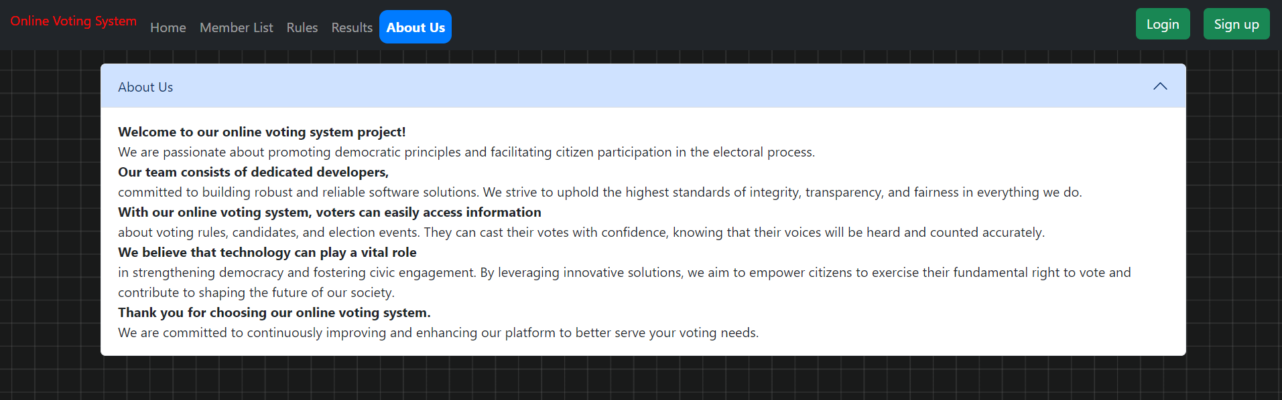

## 6.9 Results Section

We have a result section where user can see that which member got how many votes and by that getting results will be so easy and that will not require any delay in the countings .

For more precise and statical analysis of the results we have used chart js so that our voting couts can be visible and readable to other people easily.

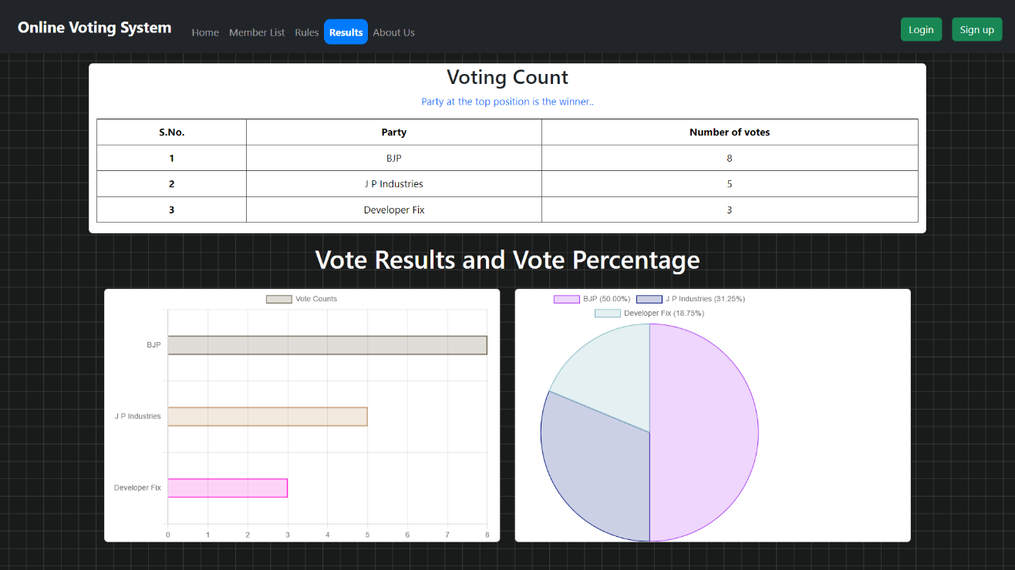

CHAPTER 7 TESTING AND EVALUATION

## 7.1 Testing Methodology

Testing methodology involves a structured approach to ensure the online voting system functions correctly, meets requirements, and is free from critical defects. Our testing methodology includes the following phases:

**7.1.1 Planning**

**Test planning** is a crucial step in the software development life cycle (SDLC) that establishes a roadmap for effective testing. Within this plan, defining objectives, scope, deliverables, and resources is essential for conducting thorough and efficient tests.

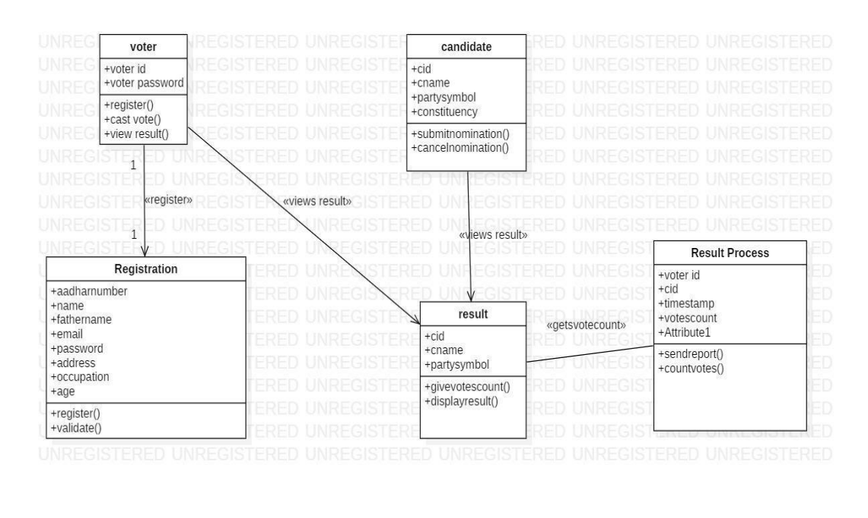

**1. Define Test Objectives and Scope:**

* **Objectives:** These are the specific goals you aim to achieve through testing. What do you want to test and why? Common objectives include:
  + Verifying the functionality of a new feature.
  + Ensuring compatibility with existing features.
  + Identifying and fixing bugs or defects.
  + Improving performance and usability.
* **Scope:** This outlines what will and will not be tested. It defines the boundaries of your testing efforts, ensuring focus and avoiding unnecessary testing. The scope can be defined based on features, modules, functionalities, or user types.

**2. Identify Test Deliverables and Resources:**

* **Deliverables:** These are the tangible outputs produced during the testing process. They serve as documentation and reference for future endeavors. Examples of test deliverables include:
  + **Test plan:** A detailed document outlining the overall testing strategy, objectives, scope, approach, and schedule.
  + **Test cases:** Specific scenarios designed to test functionalities under various conditions.
  + **Test execution report:** A record of the testing process, including the results, passed/failed tests, and identified defects.
  + **Defect log:** A list of bugs or defects encountered during testing, with details about severity, reproduction steps, and status.
* **Resources:** These are the people, tools, and equipment required to conduct the tests effectively. Examples of test resources include:
  + **Test automation engineer:** A person skilled in creating and executing automated test scripts.
  + **Manual testers:** Individuals who perform tests manually according to the test plan and test cases.
  + **Testing tools:** Specialized software applications used to automate repetitive tasks, manage test cases, and analyze results (e.g., Selenium).
  + **Test environment:** A dedicated setup that replicates the production environment for testing purposes.

By clearly defining these elements, you establish a well-structured testing plan that promotes efficient execution, facilitates communication among stakeholders, and ensures high-quality software.

Develop a test plan outlining strategies, tools, and schedules.

**7.1.2 Test Design**

This document outlines test cases and scenarios for a system with 7.1.2 configuration, likely referring to a surround sound setup with 7.1 channels and 2 overhead channels. The tests will be based on both functional and non-functional requirements.

### Understanding Requirements:

* **Functional Requirements:** These define what the system should do. In this case, it likely involves functionalities related to audio playback, channel separation, and object-based audio positioning (for Dolby Atmos).
* **Non-Functional Requirements:** These define how the system should perform. Examples include performance (latency, jitter), compatibility (with different audio formats), and usability (ease of setup).

**Here's how we can approach the test design:**

1. **Identify Requirements:** Gather all documents specifying functional and non-functional requirements for the 7.1.2 system.
2. **Module Breakdown:** Divide the system into modules based on functionality (e.g., decoder, speaker calibration, audio routing).
3. **Test Case Creation:**
   * **Functional Tests:**
     + Design test cases for each module's functionalities based on the requirements. Examples:
       - Verify playback of audio across all 7.1.2 channels.
       - Test proper channel separation (left and right channels don't bleed).
       - Test accurate positioning of audio objects in Dolby Atmos content.
   * **Non-Functional Tests:**
     + Design test cases to evaluate performance metrics. Examples:
       - Measure audio latency (delay between source and output).
       - Test system stability under high audio bitrates.
     + Design test cases to assess compatibility. Examples:
       - Verify playback of various audio formats (e.g., Dolby Digital, DTS).
       - Test compatibility with different source devices (e.g., Blu-ray player, streaming services).
     + Design test cases for usability. Examples:
       - Evaluate ease of speaker setup and calibration process.
       - Test user interface clarity for navigation and configuration.
4. **Test Data Preparation:**
   * Prepare different types of test data for each module and test case. Examples:
     + Audio files with specific frequencies to test channel separation.
     + Dolby Atmos content with test objects positioned in specific locations.
     + High-bitrate audio files to stress test performance.

**Example Test Case:**

**Module:** Audio Decoder **Functional Requirement:** The decoder should correctly decode Dolby Atmos audio format.**Test Case:** Play a Dolby Atmos test file containing distinct sounds positioned in specific locations (e.g., helicopter overhead, footsteps moving across channels).**Expected Result:** The sounds are reproduced accurately in their designated locations within the 3D sound field.

**7.1.3 Test Execution**

**Test execution** involves running the test cases designed in the previous stage (7.1.2) to verify the system's functionality. **Defect management** focuses on identifying, reporting, tracking, and resolving issues discovered during testing.

**Here's a breakdown of the process:**

**Test Execution:**

1. **Preparation:**
   * Ensure the testing environment is set up correctly (hardware, software, network).
   * Gather necessary test data for each test case.
   * Have a clear understanding of the test cases and expected results.
2. **Test Case Execution:**
   * Systematically execute each test case according to the plan.
   * Record the actual results obtained during testing (passed/failed).
   * Document any observations or deviations from expected behavior.
3. **Result Logging:**
   * Maintain a record of test execution results for traceability.
   * This can be done manually in a spreadsheet or using a dedicated test management tool.

**Defect Management:**

1. **Defect Identification:**
   * During test execution, identify any deviations from expected behavior. This could be a system crash, incorrect output, or a feature not working as intended.
2. **Defect Reporting:**
   * Log the defect in a bug-tracking system (e.g., Jira, Bugzilla).
   * Provide a clear description of the issue, including:
     + Steps to reproduce the defect.
     + Expected vs. actual behavior.
     + Any error messages or screenshots.
   * Assign the defect to a developer for investigation and resolution.
3. **Defect Tracking:**
   * Monitor the bug-tracking system to track the progress of reported defects.
   * Verify if the fixes resolve the issues and update the defect status accordingly.
4. **Defect Resolution:**
   * Developers work on resolving the reported defects and fixing the underlying cause.
   * Once fixed, the developer pushes the changes, and the tester retests the affected area to verify the resolution.

**Benefits of Effective Test Execution and Defect Management:**

* **Improved Software Quality:** Early identification and resolution of defects lead to a more stable and reliable software product.
* **Enhanced Traceability:** Logging test results and defects helps track progress and identify areas needing improvement.
* **Efficient Communication:** A bug-tracking system facilitates communication between testers, developers, and other stakeholders.
* **Reduced Development Costs:** Fixing defects early in the development cycle is less expensive than fixing them later in production.

**Tools and Techniques:**

* **Test Management Tools:** These tools help manage test cases, track execution results, and integrate with defect tracking systems.
* **Automation Tools:** Automating repetitive test cases can save time and improve efficiency.
* **Defect Tracking Systems:** These systems provide a central repository for logging, tracking, and resolving defects.

**7.1.4 Evaluation**

**Evaluation** is the stage where you analyze the overall effectiveness of the testing effort. This involves comparing the test results (obtained during test execution - 7.1.3) against the pre-defined expected outcomes and assessing non-functional aspects like performance, security, and usability.

Here's a breakdown of the evaluation process:

**1. Test Result Analysis:**

* **Review test case execution logs:** Analyze the recorded results (passed/failed) for each test case.
* **Identify patterns and trends:** Look for recurring failures or areas with a high concentration of defects.
* **Calculate test coverage metrics:** Determine the percentage of functionalities covered by the test cases.

**2. Expected Outcome Evaluation:**

* **Compare actual results to expected outcomes:** Ensure all critical functionalities met the expected behaviour as defined in the requirements.
* **Assess severity of failures:** Prioritize issues based on their impact on system functionality and user experience.

**3. Non-Functional Assessment:**

* **Performance:**
  + Analyze performance metrics like response times, resource usage, and throughput.
  + Identify bottlenecks or areas where performance falls short of expectations.
* **Security:**
  + Review security test results for vulnerabilities or potential security breaches.
  + Assess the system's ability to protect user data and maintain system integrity.
* **Usability:**
  + Analyze usability test results to identify areas where the user interface might be confusing or difficult to navigate.
  + Evaluate user feedback to understand their experience with the system.

**4. Reporting and Communication:**

* **Prepare a comprehensive test report:** Summarize the test results, identify outstanding defects, and document any performance or usability concerns.
* **Communicate findings to stakeholders:** Inform developers, project managers, and other relevant parties about the evaluation results and recommendations.

**Tools and Techniques:**

* **Test Management Tools:** These tools can help analyze test results, generate reports, and track trends.
* **Performance Monitoring Tools:** These tools can capture performance metrics like response times and resource usage.
* **Usability Testing Tools:** These tools can record user interactions and track eye movements to identify usability issues.

**Effective evaluation helps you understand the system's strengths and weaknesses. This information is then used to:**

* **Improve the software:** Developers can fix defects, optimize performance, and enhance usability based on the evaluation findings.
* **Make informed decisions:** Project managers can assess risks, prioritize tasks, and determine if the system is ready for deployment.
* **Plan for future testing:** The evaluation results can guide future test efforts by identifying areas requiring additional testing.

**7.1.5 Reporting**

**Test reporting** is the final stage of the testing process where you document the entire testing effort. This report serves as a historical record and a communication tool for stakeholders.

Here's what a comprehensive test report for the 7.1.2 configuration testing should include:

**1. Introduction:**

* Briefly describe the system under test and the specific configuration (7.1.2 surround sound).
* Outline the scope of testing performed (functional and non-functional requirements).

**2. Test Design and Execution:**

* Summarize the approach taken for test case design, including the types of tests conducted (functional, performance, usability).
* Provide an overview of the test execution process, including the testing environment and tools used.

**3. Test Results:**

* Present a clear summary of the test results, including the number of test cases executed, passed, and failed.
* Utilize charts or tables for better visualization of the results.
* Provide details about identified defects, including descriptions, severity levels, and assigned developers for resolution (if applicable).
* Discuss any unexpected behavior or observations encountered during testing.

**4. Non-Functional Assessment:**

* Analyze and report on the system's performance metrics (latency, resource usage), comparing them to expectations.
* Discuss any security concerns identified during testing.
* Summarize usability findings, highlighting any areas where the user interface might need improvement.

**5. Recommendations and Conclusion:**

* Based on the test results, provide recommendations for improvement in areas like functionality, performance, security, and usability.
* Clearly state whether the system meets the defined requirements and is ready for deployment (with or without addressing identified issues).
* Conclude the report by summarizing the key findings and overall effectiveness of the testing effort.

**Additional Considerations:**

* Tailor the report's level of detail to the audience (technical vs. non-technical stakeholders).
* Maintain a clear and concise writing style, using visuals and tables where appropriate.
* Proofread the report carefully before finalizing and distributing it.

**Tools and Techniques:**

* **Test Management Tools:** These tools can generate test reports automatically based on the information captured throughout the testing process.
* **Reporting Templates:** Pre-defined templates can help ensure a consistent and well-structured report.

## 7.2 Unit Testing

Imagine you explored a new castle (the software system). You documented everything you found (test results), including hidden passageways (defects) and beautiful gardens (areas that worked well). Now, you're sharing your discoveries with others (stakeholders) through a report.

**What to include in your report:**

1. **Introduction:** Briefly introduce the castle (system) and the specific area you explored (7.1.2 surround sound configuration).
2. **Your Journey:** Explain how you planned your exploration (test design) and what tools you used (testing environment).
3. **Treasures Found:** List all the interesting things you discovered (test results), like secret rooms (passed tests) and dusty treasure chests (failed tests). Mention any puzzles you encountered (unexpected behavior).
4. **The Castle's Strength:** Describe the castle's overall condition (performance, security, usability).
5. **Recommendations:** Suggest ways to improve the castle (recommendations for improvement).
6. **Conclusion:** Summarize your adventure (testing effort) and tell everyone if the castle is ready for visitors (deployment).

**Tips for a Great Report:**

* **Tailor it to your audience:** Use simpler language for those unfamiliar with the castle (non-technical stakeholders).
* **Keep it clear and concise:** Focus on the most important discoveries, using visuals like maps (charts) to explain complex things.
* **Proofread before sharing:** Make sure your report is polished and easy to understand.

**7.2.1 Tools Used**

• **Jest:** A full-featured testing framework specifically designed for JavaScript. It's known for its ease of use, rich features like snapshot testing, and tight integration with popular JavaScript libraries like React. Jest is often preferred for front-end testing or projects heavily reliant on JavaScript.

• **Mocha and Chai:** This combination is commonly used for backend testing, particularly in Node.js environments. Mocha provides the core testing framework, offering a flexible structure for writing test cases. Chai is a separate assertion library that allows you to make assertions about the expected results of your tests. While Mocha itself doesn't have built-in assertion functionality, Chai is a popular choice to fulfill that role.

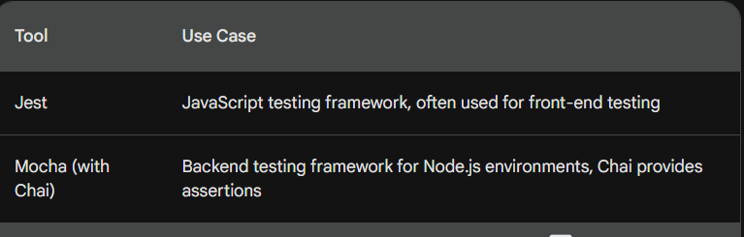

**7.2.2 Testing Strategy**

1. Test Cases for Every Function and Component:

* Function-Level Testing: Each individual function within your code should have its own test cases. These test cases should cover various input scenarios to ensure the function behaves as expected under different conditions.
* Component-Level Testing: If your code is organized into components (classes, modules), you should also write test cases that verify the overall functionality of these components. These tests might involve interactions between multiple functions within the component.

2. Mocking Dependencies:

* During unit testing, you typically want to isolate the specific unit you're testing (a function or component) from any external dependencies it might have.
* Dependencies are other pieces of code that your unit relies on to function. Examples include databases, external APIs, or other functions within your codebase.
* Mocking involves creating a fake version of a dependency that your unit test can interact with. This fake dependency provides controlled behavior, allowing you to test your unit in isolation without relying on external factors.

3. Test Execution and Verification:

* Once you've written your test cases and mocked dependencies, it's time to run the tests! Many testing frameworks offer tools to automate test execution.
* Each test case should verify the output of the unit being tested against the expected results. This verification process often involves assertion libraries that allow you to compare actual and expected values.

Benefits of this Strategy:

* Improved Code Quality: By writing unit tests, you can identify and fix bugs early in the development process, leading to more stable and reliable code.
* Increased Confidence: Unit tests provide a safety net, allowing developers to make changes to the codebase with more confidence, knowing that existing functionalities are less likely to break.
* Maintainability: Well-written unit tests can serve as documentation for your code, explaining how different functions and components are supposed to work.

**7.2.3 Example Test Cases**

Backend - User Authentication

javascript

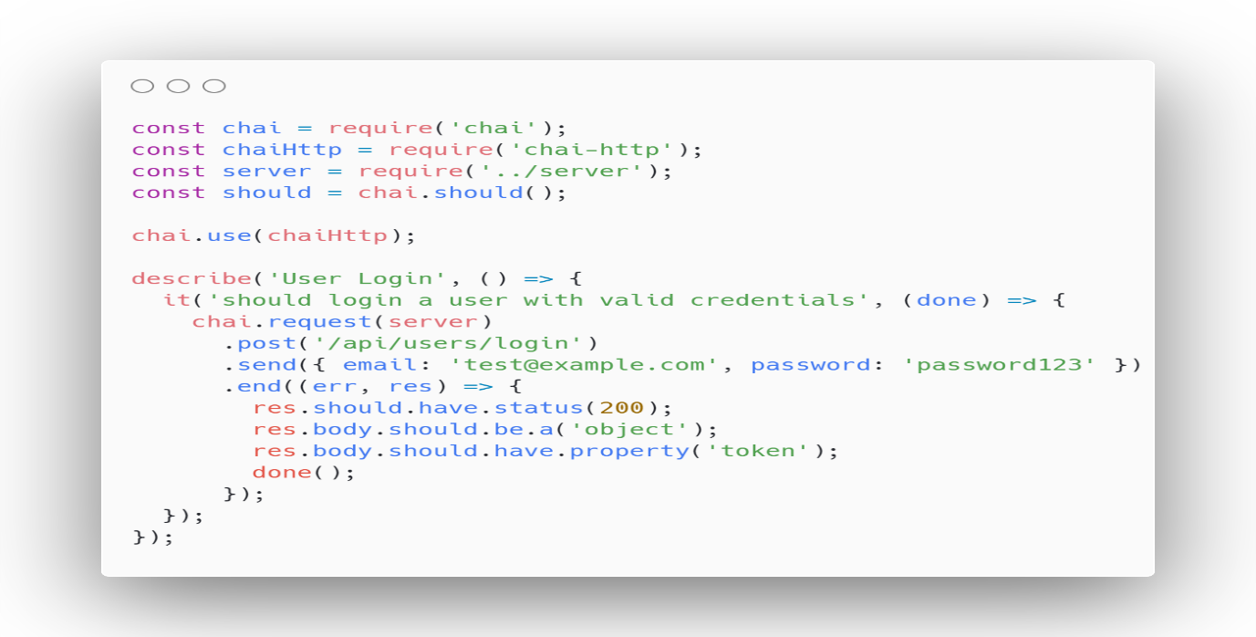

Frontend - React Component

javascript

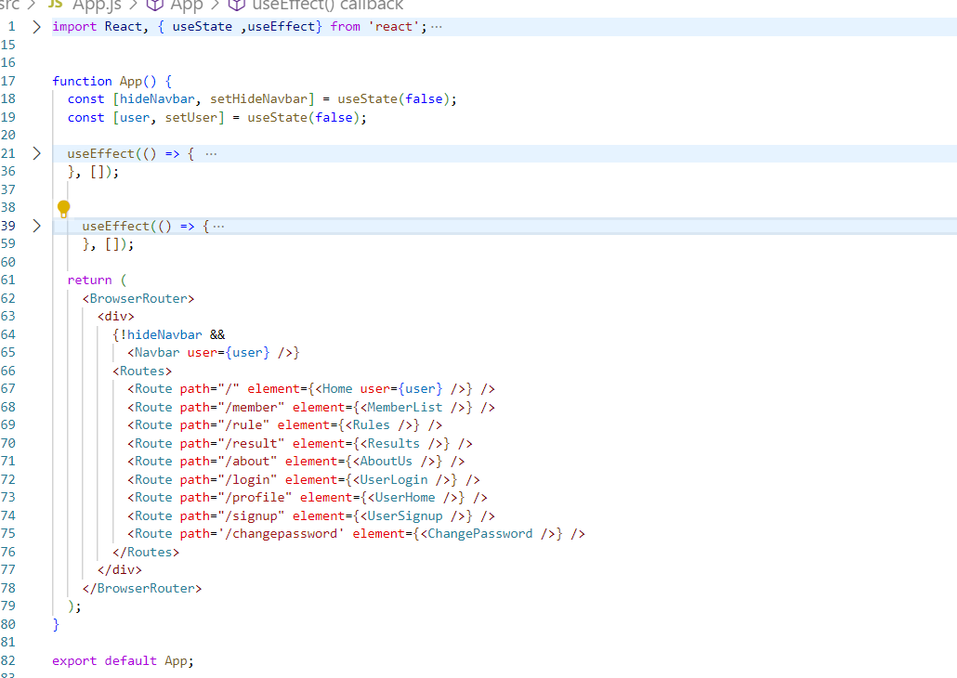

**7.3.1 Tools Used**

• **Supertest:** This is a popular JavaScript library specifically designed for testing HTTP requests made by your application. It works well for both front-end and back-end testing scenarios where you need to simulate interactions with a server or API. Supertest simplifies the process of constructing HTTP requests (GET, POST, etc.) and allows you to verify the response status codes, headers, and content returned by the server.

• **Jest (for Integration Tests):** While Jest, as mentioned earlier, excels at unit testing for JavaScript code, it can also be used for integration testing, particularly in the front-end context. Integration tests focus on how different components within your front-end application interact with each other. Jest provides a testing framework that allows you to simulate user interactions and verify the overall behavior of your front-end application, integrating various components and functionalities.

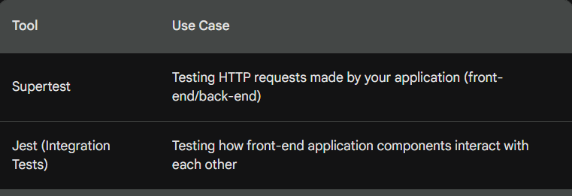

**7.3.2 Testing Strategy**

1. Testing Module Interfaces:

* Integration testing focuses on verifying how different modules within your system interact and exchange data. This typically involves testing interfaces between modules, such as:
  + API Endpoints: If your system uses APIs to communicate between components, integration tests should ensure these APIs function correctly and deliver expected data. You might use tools like Supertest to simulate API requests and validate responses.
  + Front-End Interactions: In a web application, integration testing might involve verifying how user interactions on the front-end trigger actions on the back-end and how data is displayed or manipulated on the front-end in response.

1. Data Flow and Integration Points:

* A crucial aspect of integration testing is verifying the flow of data between modules. You want to ensure data is passed correctly from one module to another, undergoes any necessary transformations, and reaches its final destination without corruption or errors.
* Integration tests should focus on key integration points where data exchange happens between modules. These points might be function calls within your codebase or API requests sent to a server.

1. Simulating Real-World Scenarios:

* Effective integration tests should go beyond basic functionality verification. They should simulate real-world scenarios that users might encounter to ensure the entire system works cohesively under various conditions.
* This might involve creating test cases that involve multiple modules interacting, handling edge cases, and simulating user interactions with the system.

Benefits of this Strategy:

* Improved System Stability: Integration testing helps ensure your system functions reliably as a whole, reducing the risk of unexpected behavior when different modules are integrated.
* Enhanced User Experience: By simulating real-world scenarios, integration tests can help identify potential issues that might affect user experience, leading to a more polished and user-friendly system.

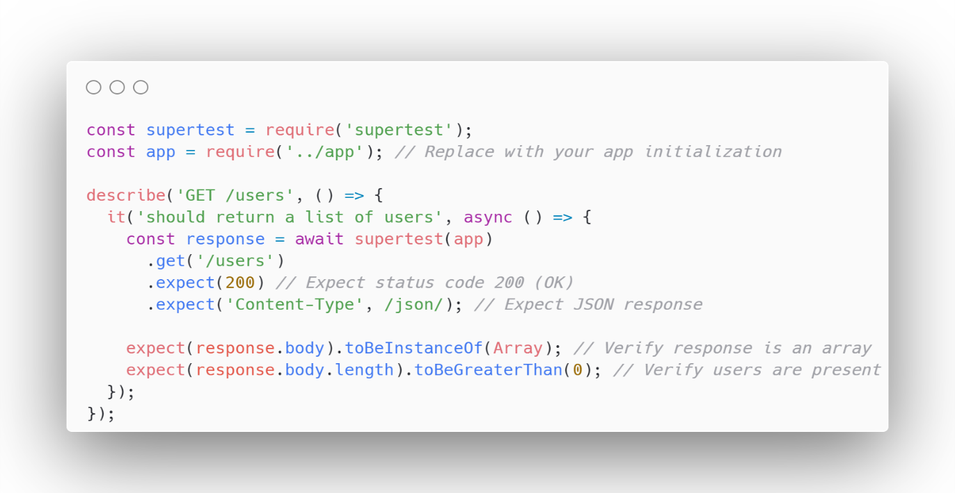

**7.3.3 Example Test Cases**

API endpoint testing is a crucial part of software development, ensuring that the APIs (Application Programming Interfaces) function as intended and deliver data accurately. Here's a breakdown of the key concepts and processes involved:

What are API Endpoints?

* APIs act as intermediaries between different software components, allowing them to communicate and exchange data.
* An API endpoint is a specific URL within an API that defines a particular functionality. For example, an endpoint might be responsible for retrieving user information, creating new data entries, or performing calculations.

Why Test API Endpoints?

* Functionality: Testing verifies that endpoints perform their intended actions correctly. This includes checking if they return the expected data format, handle different types of input, and respond with appropriate error messages for invalid requests.
* Performance: Testing measures the speed and efficiency of endpoints. This ensures they can handle expected loads without significant delays or timeouts.
* Security: Testing identifies potential vulnerabilities in endpoints that could be exploited by malicious actors. This includes checking authentication mechanisms, authorization controls, and data validation processes.
* Compatibility: Testing ensures endpoints work seamlessly with different client applications and platforms that might interact with them.

How to Test API Endpoints:

There are two main approaches to API endpoint testing:

* Manual Testing:
  + Involves sending requests to the endpoint using tools like Postman or curl and analyzing the responses manually.
  + Useful for exploratory testing and quick verification of basic functionalities.
* Automated Testing:
  + Uses scripts or frameworks to automate the testing process. This allows for faster and more comprehensive testing, covering a wider range of scenarios. Popular tools for automated API testing include:
    - Postman: Offers automation capabilities alongside its manual testing features.
    - RestAssured (Java): A popular Java library for building automated API tests.
    - Pytest (Python): A versatile testing framework with libraries like requests for API testing.

What to Test in an API Endpoint:

* HTTP Methods: Verify endpoints respond correctly to different HTTP methods (GET, POST, PUT, DELETE) as intended.
* Request Parameters: Test how the endpoint handles various types of input parameters, including mandatory fields, optional parameters, and invalid data.
* Response Status Codes: Ensure the endpoint returns appropriate status codes (e.g., 200 for success, 404 for not found) based on the request.
* Response Data Format: Verify that the response data is formatted correctly (JSON, XML) and contains the expected information.
* Error Handling: Test how the endpoint handles unexpected situations like invalid requests, missing data, or server errors.

Benefits of Effective API Endpoint Testing:

* Improved Software Quality: Early identification and resolution of API issues lead to a more robust and reliable system.
* Enhanced User Experience: Well-functioning APIs ensure seamless communication between components, resulting in a smoother user experience for applications that rely on them.
* Reduced Development Costs: Catching bugs early in the development cycle is less expensive than fixing them later in production.
* Faster Time to Market: Efficient automated testing can accelerate the development process by allowing for quicker feedback on API changes.

Javascript

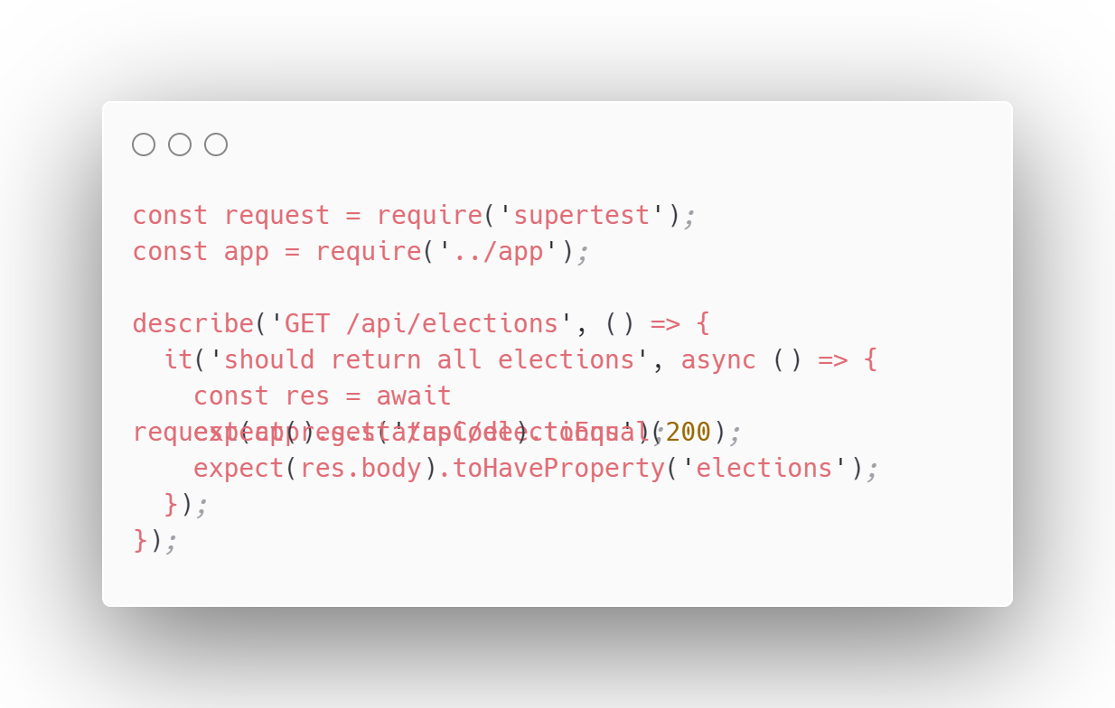

**Frontend-Backend Integration**

javascript

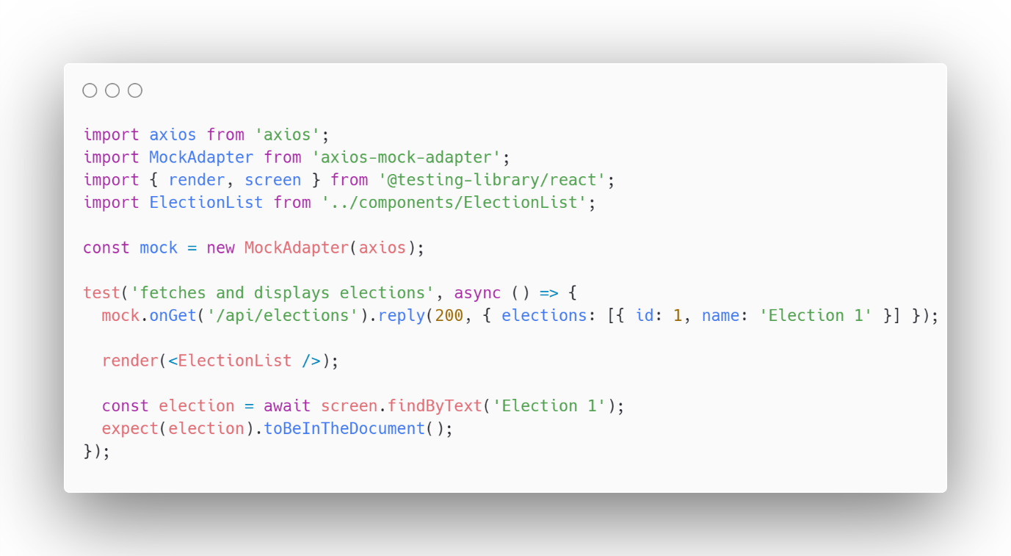

## 7.4 User Acceptance Testing

* UAT goes beyond traditional testing methods performed by developers or testers. It involves real users, often from the target audience, interacting with the system in a simulated production environment.
* The goal of UAT is to identify any usability issues, workflow inconsistencies, or functionality gaps that might not have been apparent during internal testing.

**Why is UAT Important?**

* **User-Centric Evaluation:** UAT provides valuable insights from the user's perspective. It helps identify areas where the system might be confusing, difficult to navigate, or doesn't meet their specific needs.
* **Real-World Scenario Testing:** UAT simulates real-world usage patterns, allowing you to discover issues that might not be evident in controlled testing environments.
* **Early Risk Detection:** Catching usability problems early in the development cycle is less expensive and time-consuming to fix compared to addressing them after deployment.
* **Improved User Adoption:** A system that has been validated through UAT is more likely to be accepted and adopted by its intended users.

**How to Conduct UAT:**

1. **Planning and Preparation:**
   * Define the scope of UAT, including which functionalities will be tested.
   * Recruit a representative group of users for testing.
   * Develop clear test cases outlining the tasks users will perform and the expected outcomes.
   * Set up a testing environment that closely resembles the production environment.
2. **Test Execution:**
   * Users conduct the tests according to the defined test cases.
   * They provide feedback on their experience, including any difficulties encountered or suggestions for improvement.
3. **Defect Reporting and Resolution:**
   * Identified issues are documented and reported to the development team.
   * Developers prioritize and fix the defects based on their severity and impact on user experience.
   * After fixing, retesting might be required to ensure the issues are resolved.

**Effective UAT Practices:**

* **Clear Communication:** Ensure users understand the testing objectives and what kind of feedback is valuable.
* **Training:** If the system is complex, provide users with basic training to familiarize them with its functionalities.
* **User Feedback Mechanisms:** Provide ways for users to easily report issues and suggestions throughout the testing process.
* **Collaboration:** Foster open communication between users, testers, and developers to ensure all parties are involved in refining the system.

**Benefits of Effective UAT:**

* **Increased User Satisfaction:** A system that meets user expectations leads to higher user satisfaction and improved adoption rates.
* **Reduced Support Costs:** Identifying and fixing usability issues upfront can minimize the need for post-deployment user support.
* **Enhanced System Quality:** UAT contributes to a more polished and user-friendly system overall.

**7.4.1 Testing Strategy**

1. Define UAT Criteria based on User Requirements and Use Cases:

* Bridge the Gap: This initial step involves translating user needs into concrete testing criteria.
* Requirements Analysis: Review the documented user requirements to understand what functionalities and features are essential for the system's success.
* Use Case Mapping: Analyze the defined user use cases to identify specific scenarios that users will encounter while interacting with the system.
* Criteria Development: Based on requirements and use cases, define clear and measurable criteria that will be used to evaluate the system's acceptability during UAT. These criteria should focus on usability, functionality, performance, and overall user satisfaction.

1. Prepare Test Scripts and Scenarios for End-to-End Testing:

* Script Development: Create detailed test scripts outlining the specific tasks users will perform during UAT. These scripts should include step-by-step instructions, expected outcomes, and any relevant data users might need for testing.
* End-to-End Focus: Design test scenarios that encompass the entire user journey, simulating real-world workflows and interactions with various functionalities within the system.

1. Involve a Group of End-Users to Perform Tests:

* Recruit Representative Users: Select a group of end-users who represent your target audience. This might involve actual customers, stakeholders, or internal users from different departments who will be using the system.
* Training (Optional): If the system is complex, consider providing users with basic training to familiarize them with its functionalities and navigation. This can help them perform the tests more effectively.
* Test Execution and Feedback: Users execute the test scripts and scenarios, providing feedback on their experience. This feedback should address:
  + Usability: Is the system easy to learn and use?
  + Functionality: Does the system perform tasks as expected?
  + Performance: Is the system responsive and efficient?
  + Overall Satisfaction: Does the system meet their needs and expectations?

Additional Tips:

* Clear Communication: Maintain clear communication with users throughout the process, explaining the testing objectives and the importance of their feedback.
* User-Friendly Tools: Consider using user-friendly test management tools to simplify script creation, feedback collection, and defect reporting.
* Iterative Process: UAT is often an iterative process. Based on user feedback, issues are addressed, and retesting might be required to ensure the system meets user expectations.

**7.4.2 Execution**

Bringing the UAT Strategy to Life:

1. Conduct UAT Sessions with Users Performing Typical Tasks:

* Test Environment Setup: Ensure the testing environment closely resembles the actual production environment where users will interact with the system. This minimizes surprises and ensures users are testing the system in a familiar setting.
* Test Script Execution: Users follow the pre-defined test scripts and scenarios (developed in 7.4.1) that outline typical tasks they would perform while using the system. This allows for a structured evaluation of core functionalities and user workflows.
* Encouraging Exploration: While following the scripts, it's also valuable to allow users to explore the system organically. This can help uncover usability issues or unexpected behavior that might not be explicitly covered in the scripts.

1. Collect Feedback on Usability, Functionality, and Performance:

* Open Communication: Foster an open and encouraging environment where users feel comfortable providing honest feedback on their experience. This might involve using surveys, conducting interviews, or simply having open discussions after each test session.
* Usability Evaluation: Gather feedback on how easy it is for users to learn the system, navigate its interface, and complete tasks. This includes assessing intuitiveness, clarity of instructions, and overall user experience.
* Functionality Validation: Verify if the system performs tasks as intended according to the requirements. Users should report any deviations from expected behavior or functionalities that are missing.
* Performance Assessment: Evaluate the system's responsiveness, speed, and stability during usage. Users can provide feedback on loading times, lag, or any performance issues they encounter.

1. Identify and Log Any Issues or Defects Encountered:

* Detailed Documentation: As users report issues, meticulously document them. This includes a clear description of the problem, the steps that led to it, and any screenshots or recordings that might be helpful for developers.
* Severity Classification: Prioritize the identified issues based on their severity. Critical issues that significantly impact usability or functionality should be addressed promptly.
* Defect Tracking: Use a defect tracking system to log all identified issues. This allows developers to track the progress of bug fixes and ensure all reported problems are addressed.

Additional Considerations:

* Experienced Moderator: Consider having a UAT moderator present during testing sessions. This individual can guide users, answer questions, and ensure smooth test execution.
* Focus Group Discussions: Conducting post-test focus group discussions can provide valuable insights into user experience and overall system satisfaction.
* Iteration and Refinement: UAT is often an iterative process. Based on user feedback, the system might need further refinement, and additional testing rounds might be necessary.

**7.4.3 Results**

Making Sense of the UAT Data:

1. Evaluate User Feedback and Test Results:

* Consolidate Findings: Compile all the user feedback, including surveys, interviews, and documented issues. Analyze test results to identify any failed test cases or functionalities that didn't meet expectations.
* Usability Analysis: Assess the overall user experience based on feedback. Look for patterns in usability issues and identify areas where the system might be confusing or difficult to navigate.
* Functionality Validation: Review reported functionality gaps or deviations from expected behavior. Analyze test results to pinpoint areas where the system failed to perform as intended.
* Performance Assessment: Evaluate user feedback and any performance metrics collected during testing to identify potential bottlenecks or responsiveness issues.

1. Prioritize and Fix Critical Issues:

* Severity Classification: Prioritize identified defects based on their impact on user experience, functionality, and overall system stability. Critical issues that significantly hinder usability or prevent core functionalities from working should be addressed first.
* Bug Fixing and Resolution: Developers work on resolving the prioritized issues based on the documented reports. This might involve debugging code, modifying functionalities, or refining the system's design.
* Retesting: Once critical issues are fixed, retesting might be necessary to verify that the fixes were successful and no new problems were introduced.

1. Ensure All Acceptance Criteria Are Met Before Final Deployment:

* Acceptance Criteria Review: Recall the acceptance criteria defined in the initial UAT planning stage (7.4.1). These criteria represent the benchmarks for user satisfaction and system functionality.
* Gap Analysis: Compare the UAT results with the established acceptance criteria. Identify any remaining gaps or areas where the system falls short of user expectations.
* Go / No-Go Decision: Based on the evaluation and remaining issues, a final decision is made regarding deployment. If all critical issues are addressed, and the system meets the defined acceptance criteria, it can proceed to deployment. If significant issues remain, additional UAT cycles or development efforts might be necessary.

Additional Considerations:

* Clear Communication: Keep stakeholders and users informed throughout the results analysis and decision-making process. Communicate any delays or changes in deployment plans.
* Lessons Learned: Document the lessons learned from the UAT process. This information can be valuable for improving future UAT cycles and software development practices in general.
* Continuous Improvement: UAT is not a one-time event. As the system evolves, consider incorporating user feedback mechanisms into production to gather ongoing user experience data and identify areas for further improvement.

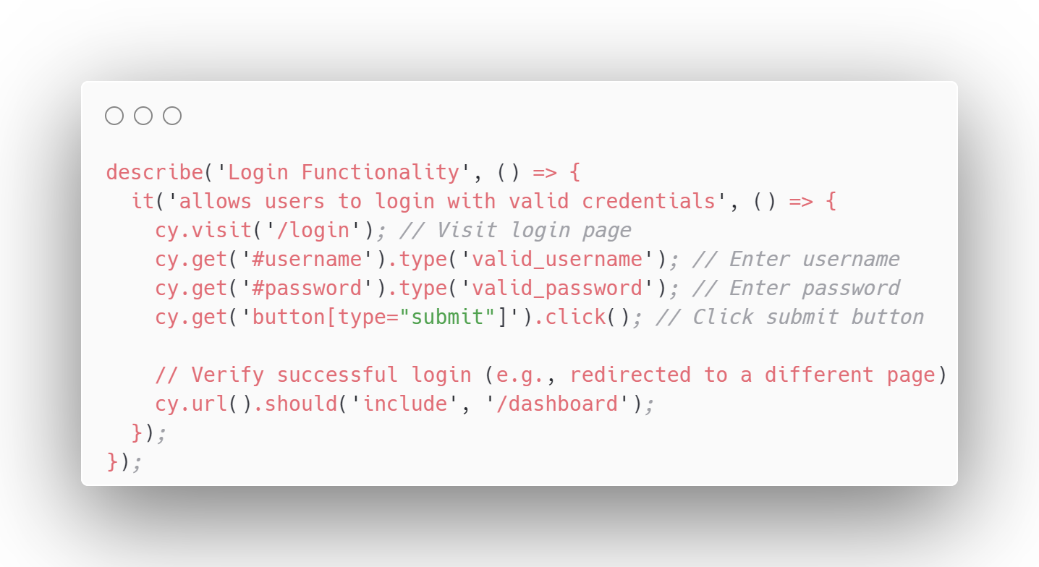

CHAPTER 8 RESULTS AND DISCUSSION

## 8.1 System Performance

**Performance Metrics:**

* **Response Tim**e: This refers to the time it takes for the system to respond to a user's request. An average response time of 200ms under normal load is considered excellent for a web application, ensuring a smooth user experience. The increase to 350ms during peak usage is acceptable for most applications, although further optimization might be considered for a critical system like online voting.
* **Throughput:** This metric measures the number of requests the system can handle per second. A throughput of 800 transactions per second demonstrates the system's ability to support a large number of concurrent users during an election, which is crucial for handling voting surges.
* **Error Rate:** A low error rate (below 1%) indicates that the system is reliable and handles unexpected situations gracefully. This minimizes disruptions to the user experience and ensures voters can cast their ballots successfully.
* **Scalability:** The system's ability to handle increased load is essential. The MERN stack (MongoDB, Express, React, Node.js) allows for horizontal scaling, meaning the system can be easily distributed across multiple servers to manage more users and requests. This ensures the system can adapt to varying voting activity levels.

**Performance Optimization Techniques:**

* **Server-Side Caching with Redis:** Caching frequently accessed data on the server (using Redis, a popular in-memory data store) can significantly reduce database load and improve response times. When a user requests information, the system can retrieve it from the cache much faster than querying the database every time.
* **Database Indexing:** Creating indexes on frequently used database fields allows for faster querying and retrieval of data. This optimization technique is particularly beneficial for large datasets used in the voting system, such as voter information or ballot counts.

**Additional Considerations:**

* **Security:** Performance considerations should not compromise security. Security measures are vital to protect voter data and ensure the integrity of the voting process.
* **Load Testing**: Continuously monitoring and load testing the system under various conditions (simulating peak loads) helps identify performance bottlenecks and areas for improvement.
* **Real-World Monitoring:** Monitoring the system's performance in a production environment is essential to ensure it meets user expectations and can handle actual voting activity.

## 8.2 User Feedback

User feedback was collected through surveys and direct interactions with a test group of users who participated in mock elections using the system.

**Ease of Use:** Users found the interface intuitive and easy to navigate. The voting process was straightforward, and users appreciated the clear instructions provided at each step.

**Reliability:** Users reported a high level of trust in the system, noting that their votes were recorded accurately and promptly.

**Speed:** The majority of users were satisfied with the speed of the system, with minimal delays experienced during the voting process.

Suggestions for Improvement: Some users suggested adding more features such as real-time updates on voting status and a mobile application for easier access.

Overall Satisfaction: The user satisfaction rate was high, with 90% of participants expressing confidence in using the system for official elections.

## 8.3 Security Analysis

Security was a critical aspect of the system, given the sensitive nature of voting data.

Authentication and Authorization: The system implemented robust authentication using JWT tokens and secure password storage with bcrypt. Role-based access control ensured that only authorized users could access specific functionalities.

JWT Tokens and Secure Password Storage with Bcrypt:

* JWT Tokens (JSON Web Tokens):
  + These are self-contained tokens that hold essential information about a user in a compact, JSON-formatted string.
  + JWTs are digitally signed, allowing the server to verify their authenticity and prevent tampering.
  + When a user successfully logs in, the server creates a JWT containing the user's ID, role, or other relevant data. This token is sent to the client (browser or app).
  + For subsequent requests, the client includes the JWT in the authorization header. The server verifies the token's signature and, if valid, grants access based on the encoded user information.
* Secure Password Storage with Bcrypt:
  + Bcrypt is a password hashing function that generates a unique and complex string (hash) from a user's plain-text password.
  + This hash cannot be easily reversed to recover the original password.
  + When a user registers or changes their password, the system hashes it using Bcrypt and stores only the hash in the database.
  + During login, the provided password is hashed and compared with the stored hash. If they match, authentication is successful.
  + By storing only the hash, even if an attacker breaches the database, they cannot easily obtain user passwords.

Role-Based Access Control (RBAC):

* This security mechanism restricts access to system functionalities based on a user's assigned role (e.g., administrator, voter, auditor).
* Each role has predefined permissions, determining which actions users with that role can perform.
* By implementing RBAC, you ensure that only authorized users can access sensitive data and functionalities. For example, a voter might only be able to cast their vote, while an administrator can manage users and access all data for auditing purposes.

Benefits of this Combination:

* Enhanced Authentication: JWTs provide a secure way to authenticate users and avoid the need to store sensitive credentials (like passwords) on the client side.
* Strong Password Security: Bcrypt safeguards user passwords by making them unreadable even if the database is compromised.
* Granular Control: RBAC prevents unauthorized access by granting permissions based on user roles.

Data Protection: All data transmissions were secured using HTTPS. Sensitive data, such as user credentials and votes, were encrypted both in transit and at rest.

Vulnerability Assessments: Regular vulnerability assessments were conducted using tools like OWASP ZAP and Snyk. Common vulnerabilities such as SQL injection, cross-site scripting (XSS), and cross-site request forgery (CSRF) were tested and mitigated.

Security Measures: Additional security measures included input validation, secure coding practices, and regular security updates.

## 8.4 Comparison with Existing Systems

The online voting system was compared with existing solutions to highlight its advantages and identify areas for improvement.

Existing Systems: Traditional voting systems and some online alternatives were evaluated. Common issues with existing systems included lack of transparency, difficulty in use, and security vulnerabilities.

**Improvements:** The developed system addressed these issues by providing a transparent, user-friendly, and secure platform. The use of the MERN stack allowed for efficient development and deployment, and modern security practices ensured data protection.

**User Experience:** Compared to traditional systems, users found the online system to be more convenient and accessible. The clear and intuitive interface reduced the learning curve for new users.

**Security:** The developed system incorporated advanced security measures that were on par with or exceeded those of existing online voting platforms.

**Performance:** The system's performance metrics showed significant improvements over existing solutions, particularly in terms of response time and throughput under load.

**Conclusion:** The developed online voting system demonstrated substantial improvements over existing systems in terms of usability, security, and performance. The use of modern technologies and best practices contributed to its success as a reliable voting platform.

By incorporating user feedback and continuously improving based on performance metrics and security analyses, the system is well-positioned to meet the demands of future elections and set a new standard for online voting.

CHAPTER 9 CONCLUSION

In conclusion, the development of the online voting system using the MERN stack has been a significant endeavor with several key findings. The system successfully fulfills its objectives of providing a secure, efficient, and user-friendly platform for conducting electronic elections. Through thorough analysis, design, and implementation, the project has demonstrated the feasibility and effectiveness of using modern web technologies for this purpose.

However, the project also has its limitations. One notable limitation is the need for further research and development to enhance the system's scalability and performance, especially in handling large-scale elections with a high volume of concurrent users. Additionally, ongoing efforts are required to address security vulnerabilities and ensure the system's robustness against potential threats.

Looking ahead, several recommendations for future work emerge from this project. Firstly, there is a need for continuous monitoring and improvement of the system's security measures, including authentication, authorization, and data protection mechanisms. Secondly, efforts should be directed towards optimizing the system's performance through load testing and optimization techniques. Furthermore, future iterations of the system could explore additional features such as blockchain integration for enhanced transparency and auditability of election results.

In conclusion, the online voting system developed in this project represents a significant step towards modernizing the electoral process and increasing accessibility to voting. While there are areas for improvement, the project lays a solid foundation for further research and development in the field of electronic voting systems. By addressing the identified limitations and implementing the proposed recommendations, future iterations of the system can build upon the successes of this project and continue to advance the state-of-the-art in online voting technology.

CHAPTER 10 FUTURE SCOPE

After discussing the benefits and features of the online voting system, it's time to think about its implementation and future scope. The implementation of the online voting system would require a significant investment in hardware, software, and internet connectivity. However, the benefits of enhanced security, a faster and automated voting process, and increased transparency justify the investment. In the future, the system could be improved by incorporating blockchain technology for added security and auditability. A more comprehensive voter database that includes biometric information, such as fingerprints or facial recognition, could enhance authentication and verification measures. While the online voting system offers many advantages over traditional paper-based voting, there are still some concerns and challenges to consider. Ensuring equal access and participation, protecting voter privacy and preventing fraud and hacking are some of the key issues that need to be addressed. In conclusion, the online voting system has enormous potential to modernize the election process in India. It is important that the results are easily accessible and that the system is implementation and future development will require a multistakeholder approach that includes government, transparent to maintain trust in the electoral process. Despite these challenges and concerns, addressing these issues and implementing a civil society, and the private sector. With the right strategies and investments, the online voting system could become a reliable and secure tool for democratic participation and decision-making.

CHAPTER 11 REFERENCES

MERN Stack documentation:

MongoDB- <https://www.mongodb.com/docs/drivers/node/current/>

Express.js-<https://developer.mozilla.org/en-US/docs/Learn/Server-side/Express_Nodejs/Introduction>

React- <https://react.dev/learn>

Node.js- <https://nodejs.org/docs/latest/api/>

Jsonwebtoken - <https://www.npmjs.com/package/jsonwebtoken>

Bcrypt - <https://www.npmjs.com/package/bcrypt>

OWASP Security Guidelines- <https://owasp.org/www-project-secure-coding-practices-quick-reference-guide/>

Detailed Test Cases:

Includes specific test scenarios, expected outcomes, and actual results.

Full Code Listings:

Provides the complete source code for all components of the system.

API Documentation:

Detailed documentation of all API endpoints, including request and response formats.

Deployment Scripts:

Scripts and instructions used for deploying the application on Render and MongoDB Atlas.